The MITCHAM HISTORIcal society
IncORPORATED NEWSLETTER

POSTAL ADDRESS: PO Box 903 Mitcham Shopping Centre S. A. 5062

Web Site: http://www.mitchamhistoricalsociety.org.au/bgHistory.htm

Mitcham Memories
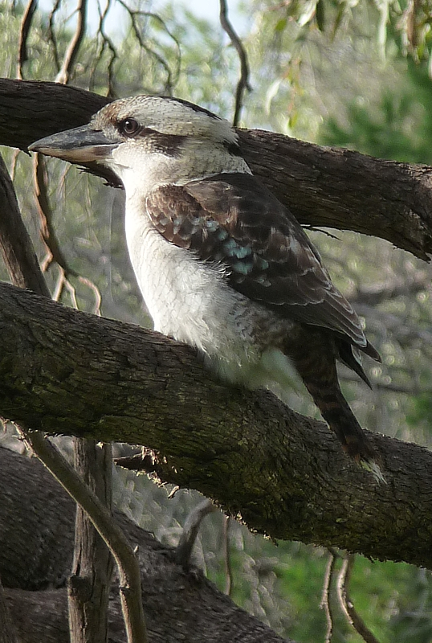

Volume 6 Number 1 December 2012

Title Page | 1 |  | Editorial | 2
Disclaimer, the Privacy Act | 3 |  | Chairperson’s Report | 4
Calendar for 2013 | 5 |  | Flier for December Break - Up | 7
Flier for February Twilight Walk 2013 | 8 |  | Mine Heritage Tour Flier | 9 9
No Dam Group News | 10 |  | New Members | 10
Brownhill Creek and Mitcham’s History – worth preserving | 12 |  | End page | 24

OFFICE BEARERS FOR 2012

Patron: | Mr.Tim Oughton | Principal Scotch College
Chairperson Julie Hogan | Julie Hogan | Tel: 0430 472 262 or 8338 3238 45676676676676676676676
Vice Chairperson/Editor | Richard Irving | Tel: 8272 9707
Treasurer | Brian Angus
Secretary | Cheryl Schneider
Committee Members | Trish Cosh | Margaret White  K
 | Rowena Atkinson | Christine Edwards
 | John Wood

EDITORIAL

Red Dog – The Pilbara Wanderer

At the entrance to the town of Dampier, W. A., there are two statues. One is of a man who was the first recorded European visitor or explorer to the area, William Dampier. The other one is a statue of a dog. No “ordinary” dog, but Red Dog – known also as The Pilbara Wanderer. The two statues are located on the left of Central Avenue as you enter the town of Dampier, where there is a small parking bay for you to safely stop and get out and take a photo of Red Dog.

Red Dog was one of a litter of three born in the Western Australian mining town of Paraburdoo in 1971, and was once owned by Col. Cummings. He was originally called Tally, which was shortened from Tally Ho. It was in 1972 that Red met John Stazzonelli. John drove the Hamersley Iron Company’s buses, and that’s how they became acquainted. Kim Douglas states that Red “teamed up briefly with a Dampier bus driver who was later killed in an accident. After John’s death in July 1975, Red Dog took up his eternal wanderings.

Soon after John’s death, Red was taken in by Ron, an electrician with Dampier Salt. Red was made a financial member of the Dampier Salt Ltd Sports and Social Club, had a bank account opened for him at the Wales, and was registered with the local shire.

The dog who became the Pilbara Wanderer did not have but one owner, but everyone’s dog wherever he travelled. He is known to have visited Roebourne, Point Samson, Port Hedland, Broome, Tom Price and Perth. His amazing homing instinct saw him always returning to Karratha or Dampier. Douglas describes him as a hitchhiker extraordinaire who enjoyed unlimited travel in cars, buses, trucks and trains.

The people of the North West are determined that his life, and what he did, will never be forgotten, they say he was unique. Even though Red Dog passed away in 1979, his story has lived on, and now thanks to Nelson Woss, our Pilbara Wanderer is known world wide. As they say, it’s not what Red Dog did, but who he was. He was no ordinary dog.

“His life, and what he did, will never be forgotten” Red Dog continues to live on, his statue has helped to preserve all that he was. As one author says, “your legend lives on”.

DISCLAIMER

Views and opinions expressed in articles in the Newsletter do not necessarily reflect the views of the Mitcham Historical Society Inc. While every effort is made to ensure the accuracy of articles printed, responsibility is not accepted for any errors they may contain that are out of the Society’s control.

THE PRIVACY ACT

A member’s personal information collected by the Society, for example name, address and telephone number, will only be used for forwarding of the Newsletter and relevant information concerning the Society. The information will not be shared, sold or given to any third party without the member’s consent. Any e-mails will be treated as above. However, any information sent by e-mail will be at the sender’s risk and the Society will not be held responsible for any unintended use or disclosure of this.

MESSAGE FROM CHAIRPERSON: JULIE HOGAN

Our AGM was held on Tuesday 25th September and this year we had 23 people attend. Ron Bellchambers, who you may be well familiar with as the spokesperson for the No Dam in Brownhill Creek Action Group, gave us an informative power point presentation on the proposed flood mitigation works throughout Brownhill Creek, Glen Osmond and Keswick creeks catchment areas. He emphasised the serious implications of these proposed works and the need for support from local community groups. This matter was raised in the AGM formalities with a proposal that the MHS offer a large donation of $3,000 to $5,000 towards the cause. After much discussion the proposal to donate $5,000 was proposed and carried by all MHS members present. The funds will be used for website/video/media/printing and production costs which will assist in promoting the issue to the public. As a historical society we need to preserve not only buildings and structures but our native environment for future generations.
Elected members remained the same as the previous year with myself as Chairperson, Rick Irving as Vice-Chairperson and Editor, Brian Angus as Treasurer, Cheryl Schneider as Secretary, John Dibben as Auditor and Rowena Atkinson, Trish Cosh, Christine Edwards, Margaret White and John Wood continuing on as committee members. As always, it goes without saying that the committee members’ efforts throughout the year are invaluable. We are in the throes of planning our 2013 programme and any suggestions for events are always welcome. (As you can appreciate, it is hard to constantly come up with exciting and informative activities that will please everyone!) Our last event for the year is the Christmas Breakup at the Edinburgh Hotel on Tuesday 11th December at 4pm. This has always been an enjoyable get-together so I hope to see you there. Have a safe and happy Christmas break.
“If someone is too tired to give you a smile, leave one of your own, because no-one needs a smile as much as those who have none to give”. S.R. Hirsch

PROGRAMME FOR 2013

MARCH (Tuesday 12th) Twilight Walking Tour – Kingswood
Time: 6pm to 8pm. Hosted by Glen Woodward. Cost: Gold coin
Meet at the community car park behind the Shell Petrol Station.
Contact: Julie Hogan: 8338 3238 or 0430 472 262
Email: julie.a.hogan@gmail.com

APRIL (Sunday 14th) Callington Heritage Mine Trail Tour
View early mines around Callington and distinctive landscapes on the Bremer River. Bus departs from Mitcham Council Car Park. Time: 9.30am
Limited seats so book early to avoid disappointment
$75.00 for members & $85 for non members
Contact: John Wood: 8373 3374 or 0402 781 601
Email: johnwood@adam.com.au
Julie Hogan: 8338 3238 or 0430 472 262
Email: julie.a.hogan@gmail.com

MAY “About Time” SA’s History Festival Activities
Brownhill Creek/Ellison’s Gully Walk Details to be advised

JUNE Proposed Scotch at Scotch Event
To be held in the Drawing Room, Scotch College. More details to be advised: Contact: Julie Hogan: 8338 3238 or 0430 472 262
Email: julie.a.hogan@gmail.com

JULY Proposed Speaker Presentation
Details to be advised Contact: Julie Hogan: 8338 3238 or 0430 472 262

AUGUST Lochend House & Lochiel Park Tour
Details to be advised Contact: Julie Hogan: 8338 3238 or 0430 472 262
Email: julie.a.hogan@gmail.com

SEPTEMBER (Tuesday 24th) AGM
Time: 7.30pm Drawing Room, Scotch College
Contact: Committee Members

OCTOBER Proposed “Investigating Barossa Wine Families” Trip
Bus departs from Mitcham Council Car Park. More details to be advised
Contact: John Wood: 8373 3374 or 0402 781 601
Email: johnwood@adam.com.au
Julie Hogan: 8338 3238 or 0430 472 262
Email: julie.a.hogan@gmail.com

NOVEMBER Proposed Glen Osmond Walking Tour.
More details to be advised

DECEMBER (Tuesday 10th) Christmas Breakup
Function at Edinburgh Hotel
Time: 4pm Contact: Committee Members

In the “Country News” columns in the South Australian Advertiser for Friday the third of April 1874, there appeared this short report:

Letter from Mr. Geo. Prince, of Mitcham, asking grant of land out of Brownhill Creek reserve to build a place of worship on of letter to be forwarded to Commissioner of Crown lands, with request that application be granted. The “place of worship” was the Baptist Chapel.
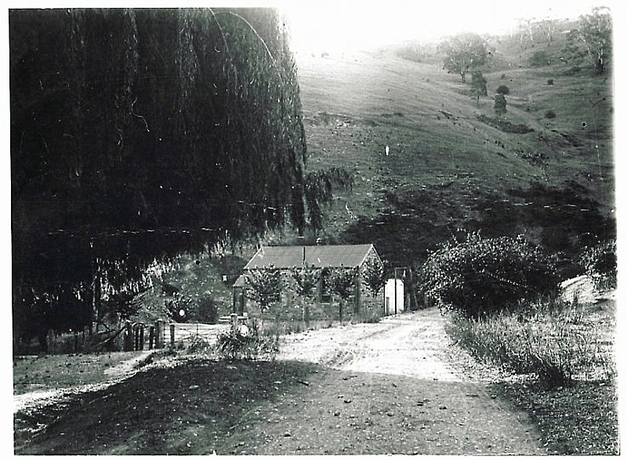


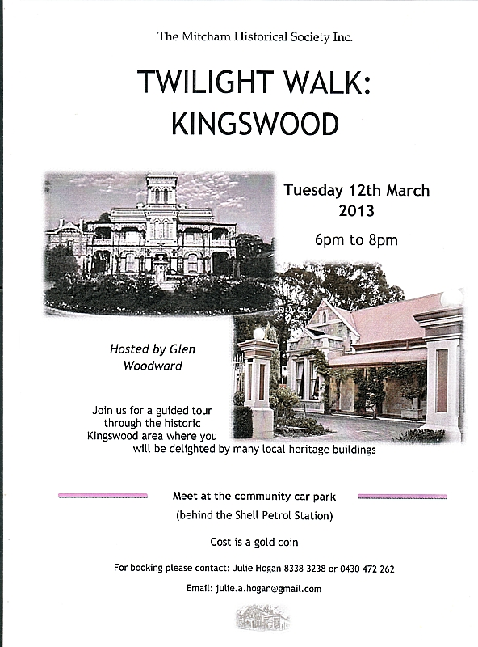
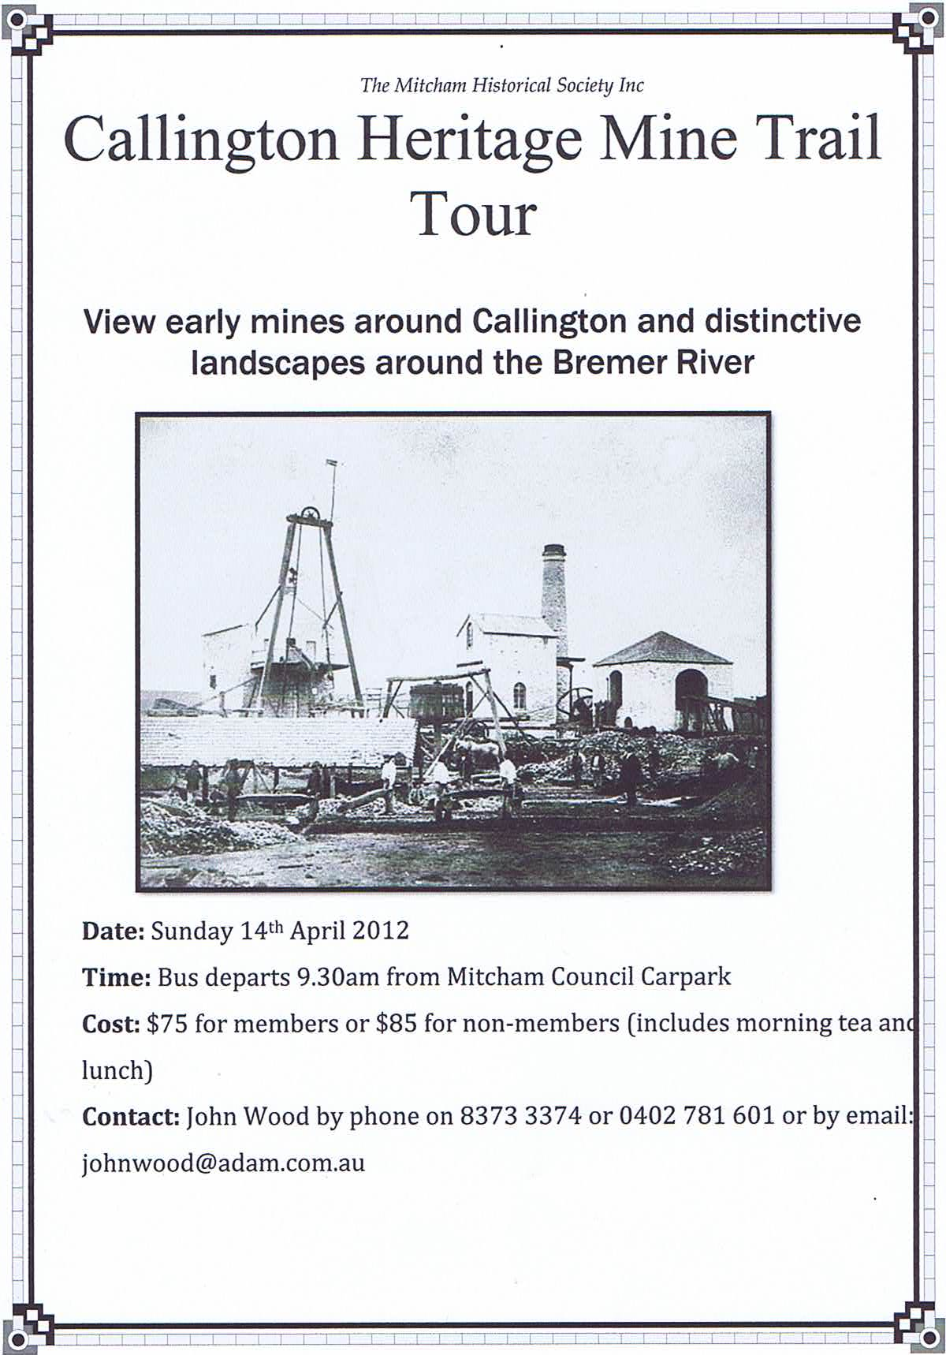


A 2012 Brownhill, Keswick Creek Draft Stormwater Management Plan, including an agreement to “ pursue a feasible No Dam solution,” has just been submitted by the five catchment councils to the Stormwater Management Authority Board for approval. The new SMA Board is expected to approve the plan, giving at least 12 months to address the issues in the Upper Brownhill Creek catchment, Part B of the plan. Part A works (80% of the project /$120m) in the Keswick Creek catchment and Lower Brownhill Creek catchment can proceed. See Mitcham Council website: home page link to Brownhill Creek Stormwater Management.

The Upper Brownhill Creek catchment, above the Glenelg Tramway, has major problems. The natural channel is in private ownership all the way up to Brownhill Creek Recreation Park. This section of Brownhill Creek is partially blocked in places and is poorly maintained, putting residents at risk from flash flooding caused by short intense rainfall over the urban area. A preliminary design/cost study is underway into the urban channel capacity to determine the extent of the problem and how to address it. The results of this study should be released in February/March 2013 and will be crucial for the final design of Part B flood mitigation works.

Avoiding urban flood mitigation is not an option, because downstream channel works, including diversion culverts, are essential to protect properties from urban flash flooding. Expanding these downstream works eliminates the need for a dam, creating sufficient capacity to handle both urban and rural flows. The No Dam option 3A is now part of the recommended Stormwater Management Strategies (page vii, 2012 plan), but a dam has not yet been ruled out and we will have to continue campaigning throughout 2013. A design/cost study into the proposed dam is about to begin and will also be completed by February/March 2013. We believe that the true cost of the dam will be considerably higher, making the No Dam option 3A cost comparable.

Brownhill Creek Recreation Park has been placed on The National Trust, 2012 At Risk Register and the towering Stone Pines at “Seven Pines” have been listed as trees of State significance. Mitcham Historical Society, The Friends of Brownhill Creek, Conservation Council SA, The Kaurna Nation Cultural Heritage Association, 8,000 signatories on the No Dam Petition and numerous other community groups, have called for the protection of the environment and heritage of Brownhill Creek Valley/Wirraparinga, sending a very powerful message. Mitcham Council has negotiated responsibly, tirelessly and cooperatively with the other four catchment councils and various authorities. We should be proud of Mitcham Council’s elected members and staff, as they are doing their best to achieve a balanced outcome.

“Seven Pines” in the Brownhill Creek Recreation Park (Site 1) has become a No Go Zone for the proposed dam, however we need to realize that if the downstream works are not successfully completed, then Ellison’s Gully (Site 2) could once again be targeted as a possible location for the dam.

THE MITCHAM HISTORICAL SOCIETY INCORPORATED

NEW MEMBERS SINCE OUR PREVIOUS NEWSLETTER

We acknowledge and sincerely welcome Laurel Bingham, Ron, Diane & Libby Bellchambers, Dudley Mitchell, Trevin & Diane Love, Tony & Louise Charlick, Jenny Monfries, Snr Mary Mercer and Ailsa Paterson who have shown support to our Society by becoming members.

Brownhill Creek and Mitcham’s History.

From the very earliest days, Brownhill Creek has been associated with Mitcham, and has therefore become part of the history of this city. Norman states that “Owing to the disastrous fire on 22nd January, 1839, which destroyed the first surveys, no records are extant to show whose was the first white foot to tread the valley of Brownhill Creek, but we know that by December, 1837, 60,000 acres had been surveyed …”

There were people in Mitcham who lived and worked in and around the Brownhill Creek valleys. The South Australian Company had taken up land in the creek valley from 1837 for their Number One Sheep Station to hold sheep overlanded to feed the colony, and had offered a “Twenty Pounds Reward” for anyone who would give information on who had ham-strung a horse of theirs the following year. It is believed that Europeans had settled the area very early, even before the survey of the Adelaide Plains was completed. In fact it is recorded that a Mr Walker and his son James were already living among the hills, in a thatched cottage, built of clay and which looked at least ten years old, when the first settlers arrived.

James and Catherine Greig had settled somewhere in the valley by 1839, as their son James was born on the 24th June 1839 , being the first recorded child born in the valley. That the name is Greig and not Grigg, is mentioned on page 3 of the South Australian for February 14th, 1845.

The Brown Hill Creek Reserve was set aside originally in 1841 for “public purposes” by the Colonial Governor, George Grey, after a sample of freestone was obtained from a quarry that was opened near Brown Hill Creek. By 1858 it was clearly defined on survey maps as a public reserve.

Joseph Gould had settled in the Brownhill Creek Valley, fencing twenty acres with posts and four rails, and two dwelling houses, one of stone, the other of wood. The land had not been sold, though had been surveyed. There were several huts, stock-yards, &c., erected, and two or three acres have been fenced by squatters, who have been located there for sometime past.

The Mitcham Historical Society states that we are “proud of our history, and committed to our future”. History is the study of the human past as it is described in the written documents left by human beings. Norman’s book is one of “the written documents left by human beings”. If we are proud of our history, it is incumbent upon us to preserve it for future generations. In its way, Norman’s book has done just that.

The valley of Brownhill Creek abounds in history, and indeed our journey through it is like a picture book, the pictures being a visual record, which reveal the sights and signs of the valley’s history. We begin our story at the stone monument which forms the entrance to the Reserve, built during the 1950’s, which states “Brownhill Creek Reserve. This area was proclaimed a National Pleasure Resort on July 15th, 1915 and is under the control of the South Australian Government Tourist Bureau.” It is significant to read that it says “National Pleasure Resort”, and that the word “Tourist” is mentioned.

The history of the valley from here on has been divided up into three sections, firstly from the monument to White’s bridge, the Lion’s picnic Ground and Rogers Quarry. The second section is from White’s Bridge to the Ford, the Manure Pits and the ruins of the Baptist Chapel, and the last section is from the ruins to the Mitcham Water Works.

Just past this stone monument at the entrance, on the first left hand curve of Brownhill Creek Road, can be seen the remains of Grainger’s Quarry. John Grainger had taken up sections of land either side of the Brownhill Creek eastwards to the Council Boundary between 1846 and 1853. Very close to the roadside edge of this quarry there was once a brick-lined well.

Close to the entrance to the Caravan Park can be seen the ruins of a crushing plant, in the form of four large concrete blocks.

Within the Brownhill Creek Caravan Park, can be seen the “Monarch of the Glen” which is a large gum tree, on the National Register of Big Trees, and reputed to be in excess of three hundred years old, and in which early settler families are reported to have stayed. The foundation stone of the former Brownhill Creek Chapel (Baptist Chapel) can be seen at the base of the tree.

The remains of a municipal swimming baths in the creek nearby date from 1893, parts of which are still visible. Bathing in the creek relieved the hot summers and in 1894 a bathing hole was formalised in Brownhill Creek. By 1901 the Council resolved that no bathing was allowed between sunrise and half an hour after sunset. However, Mitcham Council minutes of 1 December 1902 record complaints by market gardener T Newey that the baths were interfering with the natural flow of the creek and market gardening operations. The council resolved that “all dams on the creek be destroyed and no further bathing allowed.” This led to the closure of the public swimming baths.

Just before the southern end of the Caravan Park, on Brownhill Creek road, and under a large oak tree, can be seen a cast-iron drinking fountain on the right. This drinking fountain was part of the Mitcham Waterworks.

The valley has been extensively quarried, and behind the Lion’s picnic area is a historic quarry, known as Rogers Quarry. The quarry was first worked in 1860, and the stone used in many of the older buildings in Mitcham, including St. Michael’s Church. In this quarry can be seen two dry stone walls, one I believe constructed to stabilize the roadway into the quarry, and the other, recently excavated, is in the lowest valley, but its use is unknown.

Close to this picnic area and quarry above is White’s Bridge, (as it is referred to by local residents), was originally a wooden colonial structure until 1919, when Mitcham Council received a government grant to build a new reinforced concrete bridge with the contribution of local rate payers, making it one of the earliest such structures in South Australia. In the late 1990’s, the reinforced concrete sidewalls and posts were removed and replaced with metal highway railing. Henry Mundy’s son David Henry married Ellen Hermina White, which may account for the name of the bridge near here (or was it simply painted white?).

Soon after this bridge is the semicircular area of land known as the “Seven Pines”. This picturesque glen constitutes the beginning of the second section or chapter of our story.

In the Report on “The Seven Pines” at Brown Hill Creek Recreation Park, Brown Hill Creek, South Australia 5062 published in July 2012, as referred to earlier, (Footnote “F”) some very interesting historical information is given.

The purpose of this report is for the City of Mitcham to acknowledge the historical, cultural, social and scientific significance of these monumental arboricultural assets. In the August 4th 1891 Minutes of a Mitcham Council Meeting, it is recorded George Prince’s donation of seven young Stone Pines which he suggested to be planted at the “Brown Hill creek reserve”.

“Mr H. Prince offered to the Council seven young stone pine trees. He suggested they should be planted in the Brown Hill creek reserve – it would be necessary to fence them and as the fence round the lower triangle near Mrs Gardiner’s store was not required for the protection of the trees and as the fence is very dilapidated it was unanimously resolved that this fence be removed and used for protecting the trees given by Mr Prince.”

There is no mention of the planting of the Stone Pines in the Mitcham Council Records. This may indicate George was involved in the layout and planting of these Stone Pines with assistance from Council workers and/or his own gardeners. The specific number and planting pattern of six equally spaced specimens and one specimen on the opposite bank of the creek has intrigued many locals and visitors to the area for over one hundred years.

Further down on your left can be seen the stone wall ruins of Munday’s rock-crushing plant. The Munday or Mundy family operated a quarry from 1869 when Henry Mundy asked Council to be allowed to cut a road through to his property. Crushed bluestone was supplied to Council for road metal.

Walking or driving on, past the Seven Pines and the remains of the rock-crushing plant, you will eventually come to the site of the old Baptist Chapel.

The only community building to be constructed in the Brownhill Creek area was the Chapel built at the junction of Tilley's Hill and Brownhill Creek Roads. It was a branch of the Mitcham Baptist Church and Mrs Joseph Grigg laid the foundation stone in 1874. The first and only couple to be married in the chapel was Charles Orchard and Annie Grigg in 1892. The following year Chapel was opened as a school with only three teachers, Jeannie Barron, Harriett C Ward and Helen Lewin, until it closed in 1924. This building was then used as a house until it was burnt out in 1942 and 1955 before being vandalised to the foundations. A new mud-brick house is now on the site.

When the Mitcham Historical Society organize and run walks into the upper reaches of Brownhill Creek and Ellison’s Gully, we begin at the Manure Pits, east of the ford, and cross the creek near the ford.

The rich alluvial soils of the creek flats encouraged market gardening which was well established by 1891. That year Alf Terry on behalf of Council built Manure Pits after being lobbied for by Messrs Williams and Curtis. They were used to stop the pollution of the creek instead of the wet manure, back loaded from the market, being just dumped on the side to the creek to dry and become lighter.

Crossing the creek, we enter through a gate behind the mud brick house at the former Baptist Chapel, onto the property known as “Springwood Park.” It is here that the third and final section or chapter of our story begins. It is further along, in a valley described by Beresford as “rather secret” that the location of Ellison’s Gully (behind Brown Hill) can be seen.

Some might say this final chapter begins on a high point – finding gold. Just before the second gate on the property, some small workings can be seen on the northern hillside. At some time during 1932, a man by the name of John B Crocker worked this area for gold, having dug six trenches and two pits in search of the metal. However, the workings were abandoned when a bar of hard white quartz was struck. The workings were described as being near the summit of Brown Hill, east of Mitcham, and were officially known as the Brownhill Creek Gold Prospect.

If you have been with us on the walk into Ellison’s Gully you will know of the locked gate and the pedestrian access gate that we use to enter Springwood Park. We are certainly not the first to venture into the area, Europeans had settled there very early, even before the survey of the Adelaide Plains was completed. Initially the creek valley was taken up by the SA Company from 1837 for No 1 Sheep Station to hold sheep overlanded to feed the colony. William Finlayson and Samuel Sleep were two of the men employed as shepherds living along the foothills near Mitcham. Many other men, known as 'tiersmen', scaled the hills in search of timber for building purposes and firewood. Often, they just camped out, some with their families.

A report in an early newspaper stated that the land (at Brownhill Creek) had not been sold, although it had been surveyed. There were several huts, stock-yards, &c., erected, and two or three acres had been fenced by squatters, who had been located there for sometime past. In fact, a Joseph Gould had settled in the Brownhill Creek Valley, fencing twenty acres with posts and four rails, and had two dwelling houses, one of stone, the other of wood.

Some early settlers in the area had timber licences, and Samuel Ellison was one of these. The Ellison family moved to the Brownhill Creek area in late 1842 or early 1843 where Samuel leased or squatted on Crown Land and established a small farm. Their fifth child, Joseph Ellison, was born on 7th October 1843 at Brownhill Creek. Samuel Ellison was listed in James Allen's “South Australian Almanac and General Directory” of 1844 as having “three acres of wheat, one half acre of barley, one-quarter acre of potatoes and seven cattle (cows).” Samuel was one of a number of Timber getters operating in the area at the time.

Passing over the small concrete culvert and later the creek itself, we soon come to an area formerly known as Orchard’s Market Garden. The Orchard family came to Brownhill Creek Valley in the late 1870’s, when George Orchard leased an established market garden on a 22 acre property for a period of 14 years. The property was located on the second tributary of Brownhill Creek. Two generations of the Orchard family operated a market garden from 1877 to 1928, a total of 51 years. Charles Orchard took over the lease in November 1891, and operated it until 1928. John, his brother helped to run the property. The property contained a four room stone cottage and an established market garden with a cultivated area of 5 acres.

George, like many who dwelt in Brownhill Creek Valley, had cattle stolen, lost or simply strayed. I have included two such occurrences below.

LOST, from Brown Hill Creek, one Black MARE branded M near shoulder, lame near hind Leg. Ten shillings will be given for information to George Orchard, Mitcham.

10/- REWARD -Strayed or Stolen two Calves, year olds, one red, one red roan, half Jersey both branded C on rump one with yoke on. Information to C Orchard Brownhill Creek.

After passing Orchard’s Garden, which is a possible site for Thomas Moulden’s Deep Dell Brewery, we pass by a tributary of Brownhill Creek locally known as Tilley’s Creek, on which there may be another possible site for Moulden’s Brewery.

Thomas Moulden operated a Brewery at Brownhill Creek, known as the Deepdell Brewery, some four miles from Adelaide which he worked for some time. He had the lease of 10 acres more or less all of Country Section 1121 at Brownhill creek at a yearly rent of £ 15. He renewed the lease on 23rd March 1850, but by the end of the year he was in trouble financially, and borrowing money.

Writing about her journey to her brother-in-law’s Brewery and House, Mrs. J. E. Moulden stated that “The creek is a most romantic spot, and their house is completely by the mountains covered in green. But the road to it, Oh, the road! And I went there in a Dog Cart open behind. I was in a state of terror the whole time, for the great holes and large stumps of trees that we had to pass over, are only to be imagined by those who have travelled over them. When we came to the creek itself, I got out and walked the rest of the way. The banks of the stream were so dreadfully steep, that I did not dare cross it in the chaise. Imagine a little water running along the bottom this triangle and then think of delightful positions I was in having to go up and down the banks.’ It seems that Thomas Moulden and his wife Elizabeth Caroline lived on the site of the Brewery, as their first child, Caroline Evelyn was born there on the 12th of July 1850.

As to exactly where the Deepdell Brewery was situated, the records of the time simply state "Brownhill Creek", and in those days, that term would have included any tributaries.

On a rise just west of the Springfield Freehold Silver-Lead Mine can be seen a small stone circle with a central stone aligned exactly north-south. Who was actually responsible for making it, we do not know.

The Springfield Freehold Silver-Lead Mining Syndicate was situated near Eagle-on-the-Hill, two miles east from Mitcham on Brownhill Creek. Shallow adits and pits were put in, one of the old adits was extended and two shafts were sunk. Work ceased within the year. Three adits can easily be seen, but the shafts have not been located. In one of the adits, an interesting occurrence of graffiti can be seen, where “1st TORRENS 1957” has been scratched onto the adit wall.

Near this mine can be seen a small bridge over the creek. It is known as Wiley’s Bridge, and is probably not the original bridge.

After crossing this bridge, and following the creek valley in an easterly direction and passing the longer adit, we soon arrive at the site of the former Mitcham Waterworks.

As early as 1847 Brownhill Creek was considered as a possible source of water for Adelaide, but it was not until the mid-1870s that Parliament agreed to construct a water supply system on the higher reaches of Brownhill Creek. Work began on the construction of the water storage and reticulation scheme in 1878 with the survey of the pipe track, that is, the route of the pipeline from the proposed site of the Mitcham Tank and the well on Ellison’s Creek. The water reticulation scheme was officially opened on 25 November, 1879. It operated on pressure provided by the Ellison’s Creek tank, and then to the plains under pressure from the larger Mitcham tank. The system was officially discontinued in 1930, although it is highly likely it had not been in use for several years before this date.

The Waterworks today consists of a brick-lined water storage well, 137,000 litre capacity, a stone-lined valve pit, a dam wall and a settling pond. A 6 inch cast iron pipe imported from Scotland carried water along the bed of Ellison’s Creek and Brownhill Creek to the base of McElligott’s Quarry.

At two locations on the easterly track can be seen scour valves and sections of pipeline, which are part of the Mitcham Waterworks. The drinking fountain, referred to earlier, was part of this system. Still further into these hills, on another unnamed tributary was Hodge’s Market Garden. William Henry Hodge came to the Brownhill Creek Valley in 1872 when he purchased a 120 acre property on the third tributary of the Brownhill Creek, and established a Commercial Market Garden and Orchard. (Part Section 945 North, Hd. Adelaide) Two generations of the family owned and operated a market garden business on the property from 1872 to 1920.

William Hodge’s property was in the upper reaches of the third tributary of Brownhill Creek. Access to it was via a rough bullock track from Crafers. The actual market garden was along the creek, at the bottom of a steep gully. All the plots were drained by underground stone drains. It was sold to the Crown in 1920.

The track along Brownhill Creek and Ellison’s Gully continues, as does the history. There is at least one more market garden, a number of mines and around 1881, the Mitcham Dairy Company was established. Messrs Hardy & Richard Austin Horn, a Mitcham Councillor, established the Mitcham Dairy Company on October 1st, 1881. The Garden and Field Newspaper described the commencing of operations in this way: -"A dairy upon an extensive scale commenced operations on the 1st October, at Mitcham. The paddocks contain about 1,200 acres of hills, gullies, and flats. There are about 50 cows for a beginning, and more will be added as the business increases.

If we are not vigilant, or if we are seen as uncaring of it, our unique history will no longer exist. In part, our aims and objectives are to arouse interest in and to promote the study and discussion of South Australian and local history and in particular, the history of the City of Mitcham; to foster, create and maintain public awareness of the Mitcham Village and its history; to assist in the protection and preservation of buildings, works and sites of historical significance in the City of Mitcham, and, in particular, to do all such other things as are conducive or incidental to the attainment of any of the above objectives.

To do all such other things … to the attainment of … the above objectives, to actively promote the history of the City of Mitcham, to create and maintain public awareness and assist in the protection and preservation of buildings, works and sites of historical significance. History S. A. aims to PROMOTE the value, understanding and enjoyment of South Australian history, ENHANCE our community’s sense of identity by presenting a diversity of perspectives on the past, to CREATE a better understanding of South Australia’s distinctive heritage by helping to present and interpret our diverse cultural identities, and to NURTURE Community historical endeavour. They also have a vision – their vision is to inspire South Australians to reflect on the present and imagine the future, through an active engagement with their past.

Mitcham’s history, our history, is worth preserving.

CORPORATE MEMBER LOGOS

It is with pleasure that we present here the Business Logos of our Corporate Members, namely:
The Edinburgh Hotel & Cellars Adelaide Expo Hire Scotch College
Mitcham Antique Gallery Dowling City Country Mitcham Square Newsagency









POSTAGE
PAID
AUSTRALIA
PRINT
POST
PP 536729/00025
If undeliverable return to:
Mitcham Historical Society Inc.
PO Box 903 Mitcham Shopping Centre
S. A. 5062
Mitcham Memories
Print Post Approved
PP 123456/12234

Address Label

Red Dog Gillespie, N. Better Print, 2011 page 3
Red Dog Gillespie, N. Better Print, 2011 page 5
The Australian Women's Weekly, Wednesday 28 January 1981, page 13.
Red Dog Gillespie, N. Better Print, 2011 page 6
Red Dog Gillespie, N. Better Print, 2011 page 7
http://pool.abc.net.au/media/red-dog-paraburdoo
The Australian Women's Weekly, Wednesday 28 January 1981, page 13.
http://pilbaraecho.com.au/2011/07/28/roaming-red-dog-returns-home/
http://home.vicnet.net.au/~pilbregt/Red Dog/Red_dog.htm
The South Australian Advertiser, Friday 3 April 1874, page 3
Norman, W. A. History of Mitcham Corporation of the City of Mitcham, 1953, page 7.
http://www.mitchamcouncil.sa.gov.au/page.aspx?u=1358
Southern Australian, Saturday 27 October 1838, page 1
http://www.mitchamcouncil.sa.gov.au/page.aspx?u=1358
http://www.rootschat.com/forum/index.php/topic,185230.0.html
http://www.mitchamcouncil.sa.gov.au/webdata/resources/files/Brownhill_Creek_Chronology.pdf
http://www.mitchamcouncil.sa.gov.au/webdata/resources/files/Final Report on The Seven Pines at Brown Hill Creek Recreation Park.pdf page 10
South Australian Register, Saturday 10 July 1841, page 4
http://archaeology.about.com/od/hterms/qt/history_definition.htm
http://www.na tionaltrust.org.au/Assets/1127/1/HeritageLivingFebruary2012.pdf
http://www.mitchamcouncil.sa.gov.au/webdata/resources/files/ Brownhill_Creek_Chronology.pdf
Monarch of the Glen Information Board
http://www.nationaltrust.org.au/Assets/1127/1/HeritageLivingFebruary2012.pdf
http://www.mitchamcouncil.sa.gov.au/page.aspx?u=1358
http://brownhillck.org/wp-content/uploads/2012/01/PARKS_PDFS_BROWNHILL_CREEK_MP1.pdf
(http://www.mitchamcouncil.sa.gov.au/webdata/resources/files/Brown_Hill_Creek_Walk_Brochure.pdf)
https://egate.pir.sa.gov.au/minerals/new/pages/HistMineSummaryThumb/file? IMAGE_NO=1516
http://brownhillck.org/wp- content/uploads/2012/01/PARKS_PDFS_BROWNHILL_CREEK_MP1.pdf
http://www.mitchamcouncil.sa.gov.au/webdata/resources/files/Brown_Hill_Creek_Walk_ Brochure.pdf
“Report on The Seven Pines at Brown Hill Creek Recreation Park”, page 1
“Report on The Seven Pines at Brown Hill Creek Recreation Park”, page 16
“Report on The Seven Pines at Brown Hill Creek Recreation Park”, page 16
“Report on The Seven Pines at Brown Hill Creek Recreation Park”, page 16
“Report on The Seven Pines at Brown Hill Creek Recreation Park”, page 17
http://www.mitchamcouncil.sa.gov.au/webdata/resources/files/Brown_Hill_Creek_Walk_ Brochure.pdf
? http://www.mitchamcouncil.sa.gov.au/page.aspx?u=1358
? http://www.mitchamcouncil.sa.gov.au/page.aspx?u=1358
http://www.nationaltrust.org.au/Assets/1334/1/HeritageLivingSummer2011.pdf
http://www.mitchamcouncil.sa.gov.au/page.aspx?u=1358
South Australian Register, Saturday 10 July 1841, page 4
Grigg, R. The Ellison Family Mitcham Local History Collection notes, page 2.
The South Australian Advertiser, Monday 12 July 1886, page 1
The Advertiser, Thursday 12 September 1901 page 12
L. T. O.
Brummitt, B. The Moulden Family, page 62
Norman, W.A. 1953 The History of the City of Mitcham. Adelaide: Griffin Press, pp.154.
http://www.mitchamcouncil.sa.gov.au/webdata/resources/files/Mitcham_Water_Works_report.pdf page 10
? As above
? Garden & Field, November 1881, page 83.
? http://www.mitchamhistoricalsociety.org.au/aimsandobjectives.htm
? http://history.sa.gov.au/history/about_us/about_us.htm

