The MITCHAM HISTORIcal society
IncORPORATED NEWSLETTER

POSTAL ADDRESS: PO Box 903 Mitcham Shopping Centre S. A. 5062

Web Site: http://www.mitchamhistoricalsociety.org.au/bgHistory.htm

Mitcham Memories
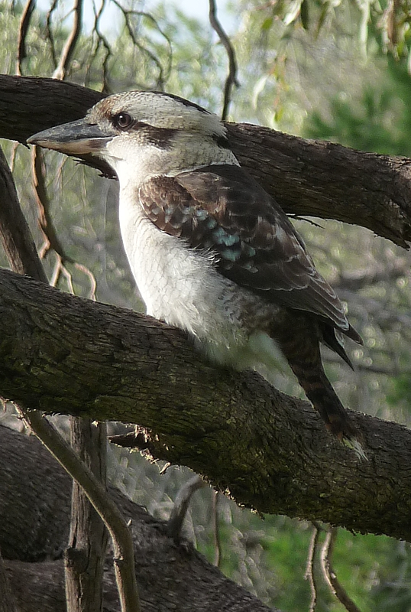

Volume 6 Number 4 September 2013

Title Page | 1 |  | Editorial, Disclaimer, Privacy Act | 2
Chairperson’s Report | 3 |  | Report / Calendar for rest of 2013 | 4
AGM Flier | 5 |  | October Smelter Chimney Walk | 6
Barossa Wine Families Flier | 6 |  | Christmas Break Up Flier | 8
Chimney Hill | 9 |  | General Information | 10
No Dam Group Report | 11 |  | Adelaide | 12
The Flying Doctor | 13 |  | Humour | 17
Picture | 18 |  | Mitcham | 19
Mr. Stuart’s Expedition | 21 |  | Mr. Moulden’s Fossils | 22
Corporate Sponsors | 23 |  | The Islander & Address details | 24

OFFICE BEARERS FOR 2013

Patron: | Mr. Tim Oughton | Principal Scotch College
Chairperson Julie Hogan | Julie Hogan | Tel 8338 3238  45676676676676676676676
Vice Chairperson/Editor | Richard Irving | Tel: 8272 9707
Treasurer | Brian Angus
Secretary | Cheryl Schneider
Committee Members | Trish Cosh | Margaret White  K
 | Rowena Atkinson | Christine Edwards
 | John Wood

EDITORIAL

Gems.

Occasionally, it is possible to find gems, real gems. Here, I do not refer to those gems from the mineral world, such as ruby, sapphire or diamond, but gems of a real historical value. They might be an article, a photograph, a document or even something else. Something of great historical value, that you did not actually expect to find at all.

There was a publication that was “Registered for Transmission by Post as a Newspaper” titled “The Children’s Hour”. (Which incidentally, cost 1½d a single copy.) Editions from the early years of the 20th Century are “of great historical value”, as they have both interesting articles and photographs in them, as well as stories, poetry and illustrations.

Occasionally, these publications can still be found, and they are like a time capsule, containing everyday information from our past.

DISCLAIMER

Views and opinions expressed in articles in the Newsletter do not necessarily reflect the views of the Mitcham Historical Society Inc. While every effort is made to ensure the accuracy of articles printed, responsibility is not accepted for any errors they may contain that are out of the Society’s control.

THE PRIVACY ACT

A member’s personal information collected by the Society, for example name, address and telephone number, will only be used for forwarding of the Newsletter and relevant information concerning the Society. The information will not be shared, sold or given to any third party without the member’s consent. Any e-mails will be treated as above. However, any information sent by e-mail will be at the sender’s risk and the Society will not be held responsible for any unintended use or disclosure of this.

CHAIRPERSON’S ANNUAL REPORT 2012/13: JULIE HOGAN
Dear members, I sincerely hope that this year has been full of successful endeavours for you all. Our events undertaken since my last Chairperson’s Report are as follows: September 2012: AGM. Committee Members elected were Julie Hogan (Chairperson), Rick Irving (Vice-Chairperson & Editor), Brian Angus (Treasurer), Cheryl Schneider (Secretary), Rowena Atkinson, Trish Cosh, Christine Edwards, Margaret White and John Wood. Our Guest Speaker was Ron Bellchambers, spokesperson for the No Dam In Brownhill Creek Action Group. It was resolved at this meeting that the society donate $5,000.00 to assist in the Brownhill Creek cause.
October 2012: Mt Lofty/Bridgewater Adelaide Hills Bus Trip, organised by John Wood. November 2012: Royal Agricultural & Horticultural Society Archives Museum Tour. December 2012: Christmas breakup celebrations at the Edinburgh Hotel. March 2013:Twilight Walking Tour of Kingswood, hosted by Glen Woodward. April 2013: Callington Heritage Mine Trail Tour organised by John Wood. May 2013: About Time History Festival with two events focusing on Brownhill Creek hosted by Ron Bellchambers and Andrew Tilley. This involved a Brownhill Creek history presentation at Scotch College and a walk through Ellison’s Gully. June 2013: Our patron, Tim Oughton gave his “Scottish Reflections” presentation, which was an insight on his exchange school visit in Scotland. August 2013: Lochend House and Lochiel Park tour – where Glen Woodward took us through a new environmentally sustainable housing development, after which we viewed Charles Campbell’s former home.

The M.H.S. greatly appreciates all the assistance Tim Oughton and his staff at Scotch College have provided for us during the year. We could not have offered such a well-received programme of events if it were not for the hard work and commitment from our committee members. Special thanks go to Rick our newsletter editor, Brian our treasurer, Cheryl our secretary, Glen our industrious tour guide and to John Wood for organising the enjoyable bus excursions. Juliet Brooke was also kind enough to take the minutes for last year’s AGM. I would also like to acknowledge, Margaret White who has been a wonderful committee member and hostess for our monthly committee meetings. Unfortunately due to health issues she has had to resign from the committee and we will greatly miss her involvement. As this year’s programme draws to a close, I would like to take this opportunity to wish everyone well for 2014.

Calendar
SEPTEMBER (Tuesday 24th) AGM
Time: 7.30pm
Drawing Room, Scotch College
Guest Speaker: Pamela Oborn
Topic: Robert Barr Smith
Contact: Committee Members

OCTOBER (Sunday 20th)
Glen Osmond Walk – Smelter Chimney
Meet at Gill Terrace Reserve at 1:30pm
Contact Rick Irving 8272 9707 or Email: irvineth@ozemail.com.au
Bring a hat, water, camera and good walking shoes.

NOVEMBER (Sunday 3rd)
Barossa Wine Families Tour
Bus departs at 9.30am from Mitcham Council Car Park
Cost: $79 for members & $89 for non members
(Includes morning tea and lunch)
Contact: John Wood: 8373 3374 or 0402 781 601
Email: johnwood@adam.com.au

DECEMBER (Tuesday 10th)
Christmas Breakup Function at Edinburgh Hotel
Time: 4pm Contact: Committee Members
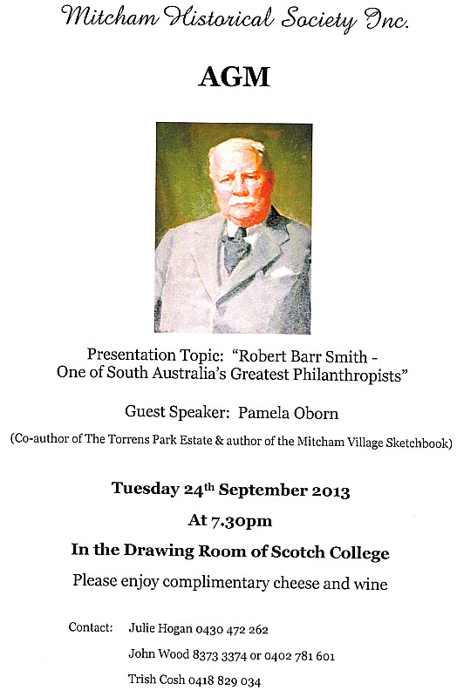

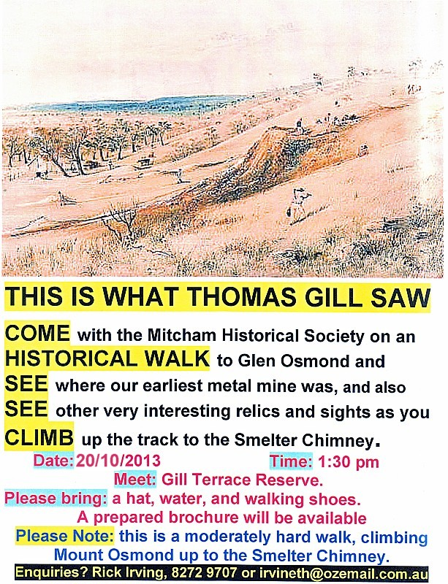

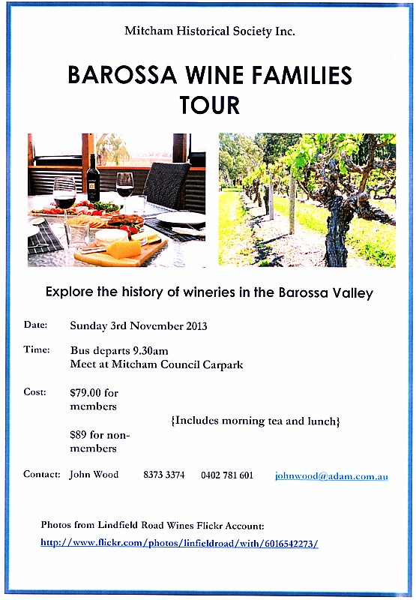

Chimney Hill

In 1916, the hill where the Glen Osmond Mines Smelter Chimney stands was referred to as “Chimney Hill” On page 9 of The Register, for Saturday 16 September 1916, there is an article stating that “The Glen Osmond Union Mining Company expended a large sum in erecting dwelling houses and smelting works. From the smelting house an underground flue led to a large circular chimney built in a conspicuous place on the north-western face. This structure was raised to carry off the fumes of the lead from the smelting of the ore. Indeed today, as you climb this hill, one of few remaining structures that relate to the beginning of Australian mining industry can be seen. Standing majestically high above the mine tunnels, the giant stone smelter chimney and flue can be seen. This chimney of the smelter was built by the Glen Osmond Mining Company in the late 1840’s.

The Observer for the 18th of August, 1849 records that “the new lead smelting works at Glen Osmond are being constructed, and a conduit chimney will be carried to the top of the hill &c, &c.” Another newspaper of that date records similar information on page 2, “The new Lead Smelting Works at Glen Osmond, which are being constructed upon sound and scientific principles, will not only be another great acquisition to the productive power of the province, but be unaccompanied with any injurious dispersion of noxious fumes. A conduit chimney will be earned to the top of the hill, and every other precautionary or economical contrivance suggested by considerations of health as well as of profit, will be combined in the new establishment.

In her book Sunny South Australia, May Vivienne, speaks of the smelter chimney in this way – “A peculiar-looking chimney, emerging from the side of the hill, is noticed by anyone driving through the pass. This was constructed to carry off the lead-fumes from the smelting-works of the Glen Osmond mine, which were situated in a gully near the hill.”

NEW MEMBERS SINCE OUR

PREVIOUS NEWSLETTER

We acknowledge and sincerely welcome Lyn Von Der Borch, Laurence and Valerie Thomson and our new corporate member, Sally Hayne who have shown support to our Society by becoming members for 2013/14.

********** SEEING STARS? **********

Do you have stars **************** on your Newsletter address label?
If you do then you have not renewed your membership and we will not be able to send you any more newsletters. Please forward your membership fees to us ASAP as support for our Society is greatly appreciated. (We thank all of you who have renewed in the meantime.)
For your convenience, these can also be paid by direct deposit:
BSB: 105-084 Account No. 045933840

Pension: $15 Individual: $25 Family: $35 Corporate: $100
##################

NOTICE OF ANNUAL GENERAL MEETING
TUESDAY 24TH SEPTEMBER 2013
Time: 7.30pm Where: Drawing Room, Scotch College
Carruth Road, Torrens Park
Guest Speaker: Mrs Pamela Oborn
Topic: “Robert Barr Smith, One of SA’s Greatest Philanthropists.”

Please come along and enjoy our hospitality with wine and cheese refreshments available.



The two reports that we have been waiting for have still not been released to the public. They are the Snowy Mountains Engineering Corporation (SMEC) report into the proposed dam at Site 1 (Seven Pines) and the AWE report into the channel capacity issues for the Brownhill Creek channel between Forestville Reserve and Scotch College.

The SMEC report has confirmed that the proposed dam would be an extreme hazard concrete dam, with a 12 metre spillway and an overall height of at least 15 metres or 5 storeys. The dam would stretch 120 metres across the valley with very similar dimensions to placing South Australia's Parliament House across the centre of Brownhill Creek Recreation Park. The concreting of the valley 30 metres downstream from the dam would occur. The cost of the dam would double from original estimates.

Despite the five catchment councils agreeing to proceed with 80% of the plan and to 'pursue a feasible no dam solution', there is a renewed push from the same group of people within government to make sure that a dam is built. We always knew that they would argue that the downstream works between Forestville Reserve and Scotch College would be too hard or costly and they are using the AWE report and every other means available to justify the building of a dam. Everyone needs to be reminded that there is a safe and feasible alternative to the dam (Option 3A), which is listed as one of the ‘Recommended Stormwater Management Strategies’ in the 2012 Brown Hill Keswick Creek Stormwater Management Plan (page vii). Downstream works are essential for flood mitigation and cannot be replaced by a dam, but a dam can be replaced by expanding downstream works.

A stormwater project will not occur without federal funding and there is now a push to secure a 30% federal contribution. The proposed dam does not comply with federal guidelines on stormwater management and the Federal Member for Boothby, Andrew Southcott MP, has taken a formal, public position opposing the dam in Brownhill Creek. Please contact Andrew Southcott to support his No Dam position. His letter can be viewed on our website: www.brownhillcreek.org.

We are entering a particularly difficult phase of the campaign, with crucial project negotiations taking place without transparency or public engagement. Mitcham Council are doing their utmost to serve the community and arrive at the best possible stormwater management plan, but they are just one player in a complex process. Rumours are emerging that Ellison’s Gully (Site 2) may well be at risk.

The Names of Our Capital Cities
Adelaide was the next city to be named. Ninety years ago times were very hard in England, and many people were unable to get employment. Edward Gibbon Wakeﬁeld, with a few of his friends, was thinking out a plan by which men who were idle in England could be brought to a new country called South Australia, where they would be able to settle on all the land they needed to work. At first the English Parliament seemed unwilling to give the control of such a big area of land to Wakeﬁeld and his friends. Then Wakeﬁeld managed to win over the help of the great soldier called the Duke of Wellington. and many members in Parliament followed the lead of the Duke. Wakeﬁeld felt so grateful that he wished to call the capital Wellington.

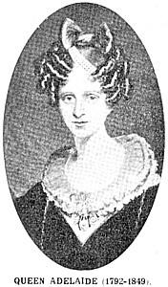
William IV was then ruling England. When a young man the King had spent many years in the navy where he had picked up many of the ways of sailors. When a paper was placed before him to sign, containing the word Wellington as the name of the new capital, the old King took up his pen, crossed out the word, and wrote above it Adelaide. He meant that the new capital was to be called after his wife, Queen Adelaide. Perhaps the King did it out of love for his wife; or maybe he felt unwilling to show any great mark of respect to the duke whose name was honoured more than the King ’s. However, whatever was the reason, King William gave us a pretty name for our capital. If Wakeﬁeld had had his way it would have been Wellington, a name that was used for a square in North Adelaide.
(The Children’s Hour, February 1926.)

THE FLYING DOCTOR.

A PEEP INTO THE FUTURE.

Every aerodrome in the future, (writes Captain Paul Bewsher in the 'Dundee Advertiser') will probably be equipped with an. aerial ambulance primarily for rendering first- aid in case of any accident to aircraft in the vicinity. This should contain two stretcher-beds, side by side or in tandem with enough room beside each for any necessary attendance to be undertaken. As soon as any aeroplane is known to be in distress, the doctor, who will always be in readiness at the aerodrome, will fly off to the scene of trouble. Even if there may not be any serious damage done, yet he may be able to attend to minor injuries which would become serious, if not treated with promptitude.

To the Rescue.

It is, however, in the event of train disasters, factory explosions, or destructive fires that an aerial medical service will be of greatest use. Doctors will be on the spot from the nearest aerodromes in a very short time, and may be able to save many lives which would otherwise have been lost for lack of swift attention. In addition to these aerodrome ambulances, there may be district air ambulance, which will fly to the scene of disasters and will take the cases to the nearest hospital. The district ambulances will per haps be directed by the local Medical Board of Health, and should prove very useful. In areas where the population is widely scattered they may be found as cheap and as swift as a motor-ambulance for sending out assistance and bringing in patients. In cases of widespread disasters, in the Halifax Harbor explosion, aerial ambulances and aerial transport generally would have proved very useful and they might help in cases of shipwreck, when a large number of patients are expected in a few hours at a small harbor town.

Hospital Landing Grounds.

There have been occasions when it has been essential to rush a specialist, a patient, or some peculiar serum or medical device across the country in order to save a human life, and success was a matter of minutes. In such instances again the aeroplane will be of vital value. It will he found that patients can be carried just as comfortably in an aeroplane as on the ground, for, in spite of its speed, the aeroplane in flight moves far more smoothly than a motor-car, and can be landed by a skilled pilot without any bumps whatever. Probably, the big general hospitals of the future will have small landing grounds beside them, so that serious cases can be taken straight to the operating-room or to a cot from the aeroplane without any time being lost. In this way the Red Cross aeroplane will be of great benefit to humanity, and will help to lessen suffering and to save life.

Captain Bewsher was rather prophetic, for the date of this report was 1919. There are some interesting statements made, which could apply to Australia. He states that “In areas where the population is widely scattered they may be found as cheap and as swift as a motor-ambulance for sending out assistance and bringing in patients.”
“There have been occasions when it has been essential to rush a specialist, a patient, or some peculiar serum or medical device across the country in order to save a human life, and success was a matter of minutes. In such instances again the aeroplane will be of vital value.” Such a statement could also apply to Australia.

The Australian Press of the time were also thinking of the ideas expressed by Captain Bewsher.

Speedy Means 0f Communication

A recent issue of "The Inlander," the official organ of the Presbyterian Inland Mission, contains the following: Speedy communication in war time calls for two branches, aeroplanes and wireless outfit. There is surely enough said in every paper everywhere to make further argument unnecessary as to the absolute need of these for Australia, so we add only the simple-looking remark that Australia's outline is a very big crumpled about circle, not a fragment thereof beginning north of Brisbane and ending near Adelaide. And if our men of the communication service are to be of any use at all, then they must know every crumple of the circle, and every occupiable point between its whole sweep and the centre.

Another very necessary firm for a defence force, and one of which we have heard comparatively little is an aerial medical service. In a far-flung line like ours such an arm is of overwhelming importance and what must be realised is that it is not to be obtained ready-made. Besides the pilots, who can wing their passenger anywhere faster than a dull man's thought, you must have doctors used to the sensation of flying: mere bravery and readiness will not enable medical men to serve in this capacity. Only picked and practised doctors can experience the peculiar antics of wings, and the wobbles in balances of body air-pressures caused by necessary lightning changes of altitude, without temporarily losing their keenness of insight, and their highest delicacy of touch.

How pleasantly an aerial medical staff could be kept fit and interested just by serving, in short relays along with the pilots, over tho wide sweep of our inland plains! Winged pilots, flying doctors; but they alone cannot save. The bush is at present, for the most part, quite dumb. Not till it becomes vocal in all its parts can it call for the help that has suddenly become so much more mobile than of old. And is there a magic touch that can give the dumb bush its tongue.

Yes, there is. Wireless is not the monopoly of the professional expert, nor the child only of the throbbing powerhouse. It condescends to be fondled by the humble amateur, and will speak at his desire, even if somewhat feebly.

Even the members of a powerful wireless body are not so alarming. Recently we stood in a quiet room looking at a box barely big enough to hold a lady's small hat, quite out of the question for the famous merry widow. It had a few trimmings on it-we refer to the box-but was ordinary enough in appearance. Yet this was the ear, vitalised by a wire from a trayful of tiny jars in which was stored current from an every-day service wire, which picked up what were petered-out ghosts of strong mystic waves discharged in England: multiplied them ad. lib.: then, becoming a tongue spoke truthfully the original message in loud intelligible buzzes, short and long!

Now, the modern bushman does not aspire to listen to the wiry gossip of London, and so needs no hat-boxful of expensiveness. But with a tiny apparatus, costing much less than an old hero of the "Bush you read about" would boose in six days, charged from a bush-rigged power producer, he could easily receive messages from very far, and send messages to mates up to fifty miles away.

We are of course counting on that new godsend, the telephonic attachment, which renders unnecessary the knack of finger and ear work demanded by telegraphy. The phone is not good enough for extreme accuracy in detail, but it will do quite well to tell the next man ninety-nine things out of every hundred-and the vital messages are ever the most easily expressed. Once plain Saltbush Bill (or rather the keen handy man who is supposed to answer that title and can keep machinery going without spare parts) gets the idea of distance talking, he will manage alright for the sake of the times when even he reckons that talking is worth while. All he needs is, firstly, practical demonstration that it can be done; and, secondly, permission from the "authorities” to do it.

Given bushmen who include baby wireless sets among their pets, the rest is easy. It can be arranged that every camp of bush folk will include one such Amateur, just as the generals hi the army engaged in the construction of our Great Western Railway made it 'their business to see that every gang included ft certificated first aid member, These amateurs will easily pass messages on from one to another, until the nearest "Homestead Plant" is reached. For every group of amateurs could arrange a central station to collect and transmit afar for nil. Thus the Government station would be worded in due course and the doctor would arrive within six hours.

Australia’s Royal Flying Doctor Service began as the dream of the Rev John Flynn, a minister with the Presbyterian Church. He witnessed the daily struggle of pioneers living in remote areas where just two doctors provided the only medical care for an area of almost 2 million square kilometres. Flynn’s vision was to provide a ‘mantle of safety’ for these people and on 15 May 1928, his dream had become a reality with the opening of the Australian Inland Mission Aerial Medical Service (later renamed the Royal Flying Doctor Service) in Cloncurry, Queensland.

RlVER MURRAY JOKE

As most people know, there are many settlements along the River Murray where delicious fruit, such as apricots, nectarines, oranges, etc., are grown. Sometime ago a traveller motoring through these fruit districts asked a Renmark man what they did with all their surplus fruit. The following was the answer: “Oh, we eat all we can, and we can all we can’t.” (1926)

ARRESTED

A funny story is told of a British soldier who was serving in Egypt. His Colonel, observing him one morning wending his way to camp with a fine Egyptian rooster in his arms, halted him to know if he had been stealing chickens. “No, colonel,” was the reply, “I just saw the old fellow sitting on the fence, and ordered him to crow for old England, and he wouldn’t, so I arrested him for a rebel.” (1925)

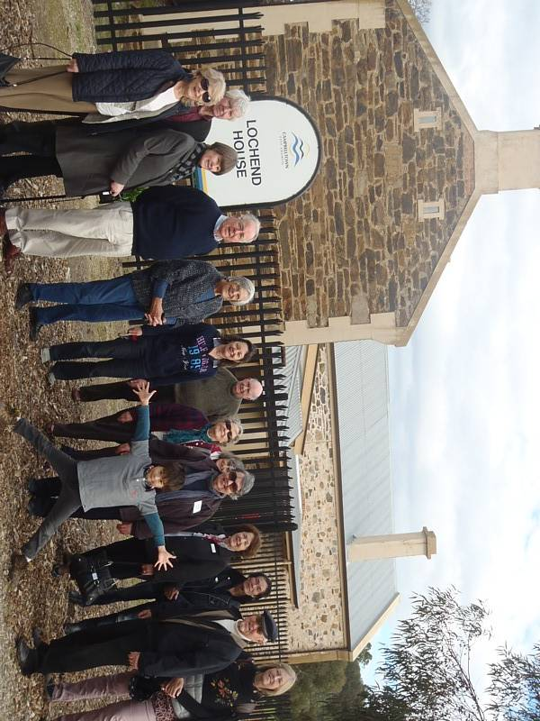

MITCHAM

AT a PUBLIC MEETING, held pursuant to advertisement on Friday Evening, the 11th instant, in the Schoolroom, Mitcham, for the purpose of considering tho best means of having the Road into Adelaide repaired, or of framing a “District Council” under the District Council Act— Chas. B. Newenham, Esq., Sheriff, in the chair. It was moved by Mr. A. L. Elder, M.L.C., seconded by Mr. Arthur Blyth, and carried unanimously— “1st That this Meeting considers it desirable that a '”District Council” should be established for Mitcham and its neighbourhood.” Moved by the Rev. Mr. Playford, seconded by Mr. Faulding, and carried unanimously. “2nd. That the boundaries of such District be on the east side, the Mount Barker-road from the Park Lands to Crafer's Inn; on the west, by the sections of land adjoining the Mitcham-road to the Hills; and on the south, by the road commonly called the Government Farm-road leading to Crafer's Inn; but that those boundaries be more particularly defined hereafter by reference to the Survey Map in the Land Office.” Moved by Mr. A. L. Elder, M.L.C, seconded by the Rev. Mr. Playford, and curried. “3rd. That the five following gentlemen, namely, Messrs. W. H. Parker, R. F. Macgeorge, Arthur Blyth, A. L. Elder, and Chas. B. Newenham, be appointed a Provisional Committee to prepare the necessary petition to His Excellency the Lieutenant-Governor.” Moved by Mr. A. L. Elder, M.L.C, seconded by Mr. Charles Platts, and carried. “4th. That this Meeting do adjourn until this day week (Friday, the 18th instant, to be held at the same place and hour), and that each owner or occupier of land within, the proposed district be invited to attend the adjourned meeting, and to bring with him a list of five qualified persons whom he wishes to vote for as Councillors for the first year; that those lists be made up in presence of the adjourned meeting, when the five names who have the most votes recorded against them be recommended to His Excellency the Lieutenant Governor as the first Council. But in the event of any of the five persons who have the most votes recorded against them declining to act, then other persons who follow in rotation having the next highest number of votes, after the five before mentioned, shall be placed in their stead.”
An adjourned Meeting will be held on Friday Evening next, the 18th instant, at the Schoolroom, at 7 o'clock.
CHAS B. NEWENHAM, Chairman.

DISTRICT OF MITCHAM

A Proclamation, constituting the ' District of Mitcham ' to be a District within the meaning and for the purposes of the District Councils Act, and defining the boundaries as follows : — Bounded by a line commencing at the south-west angle of the Park Lands ; thence in an easterly direction by the south boundary line of the Park Lands to the Great Eastern-road ; thence by the south-west side of the said road to the boundary between the Hundreds of Adelaide and Noarlunga ; thence by the boundary between the Hundreds of Adelaide and Noarlunga to its intersection with the Glenelg-road, north of and adjoining Preliminary Section No. 153 ; thence by the southern side of the Glenelg-road to the point of commencement at the south-west angle of the Park Lands. Thomas Overton, of the Grange, Goodwood-road, Benjamin Herschel Babbage, of St. Mary's, Sturt River, Peter Cumming, of Adelaide, George Styles, of Unley, and George Prince, of Mitcham, are appointed to be the first District Council.

Fire at Brownhill Creek 17 12 41

On Tuesday evening last, a fire broke out on the premises of Mr C. Whittle, stone merchant, Brown-hill Creek, originating in consequence of the window being left open, and the wind blowing the curtain into the flame of the candle, which was standing on the table in the room. We are sorry to say, that both the dwelling and out-house were destroyed, as also a chest of wearing apparel.

Mr. STUART'S EXPEDITION.

The Hon. J. BAKER said, as there was no further business before the House, he was desirous of asking a question of the Hon. the Chief Secretary in reference to Mr. Stuart's expedition. It had been reported that Mr. Stuart had been compelled to turn back in consequence of the hostility of the natives among whom he found himself. Mr. Stuart had nearly crossed the continent, and he thought it would be a pity if on this account he was prevented from enjoying the benefits of his courage and perseverance. He thought that Mr. Stuart, on his return, should be placed in a position by the Government to reap the benefits of his discoveries, which would also be of such benefit to the Government and to the country. He thought, therefore, that the Government should take steps to place Mr. Stuart in a position to go out again, with such an equipment as would be sufficient, and that the laurels which he had won would not be allowed to drop from his brow or to be borne off by another colony. (Hear, hear.) He trusted the Government would put Mr. Stuart in such a position as would enable him successfully to accomplish the work which he had so well begun. (Hear.)

The Hon. the CHIEF SECRETARY entirely agreed with the remarks of the hon. member. Mr. Baker. He thought Mr. Stuart had shown the way across the continent. That it was practicable to cross the country, and that the interior was not the arid desert which it was generally supposed to be, but that it was fit for the occupation of man and beast. He was not in a position to state the rule of action which the Government would be disposed to follow, as they had not had the intelligence alluded to much more than a few hours. In a few days, however, the Government would have doubtless decided upon their plan of action, and would immediately communicate it to Parliament. Individually he quite agreed with the hon. member, that some steps should be taken to prevent the laurels which Mr. Stuart had gained being snatched from him by others. (Hear, hear.,)
(The South Australian Advertiser, Saturday 29 September 1860, page 3

Mr Moulden’s Fossils

We have been much gratified by the inspection of a small collection of fossil shells and coral, obtained from the sandstone cliffs of the Murray. Some of the specimens are of a novel and very beautiful character, especially a nautilus, changed to a compact mass or talc, and which having been divided into three parts shews the internal structure of the shell very perfectly. We are authorised by Mr Moulden to say that he will have much pleasure in showing them to any person; but from the delicate nature, and the friable character of the sandstone of which they are partly formed, there is great objection to moving such of the shells as are formed of talc.
(South Australian Register, Saturday 19 August 1848, page 2)

On visiting a small but beautiful collection of Fossils in the possession of Mr Moulden, we were pleased to find that he offers every facility to parties wishing to see them. The five most remarkable shells, and which by some wonderful process have been converted into a transparent substance, which we believe to be talc, are the Nautilus, in three parts, showing the various cells and the air tube by which the animal rises or sinks in the water, the Fusus, a shell somewhat resembling a large whelk; the Terrebra, the Tassio, or small helmet shell, and the Venus, a shell very similar to the muscles found at the present day in the water holes and rivers of the colony. These Fossils are from the picturesque sandstone cliffs of the Murray, in which the common sandstone fossils abound; and a collection being commenced, we shall no doubt have many interesting geological specimens brought in from that locality. It may not be inopportune to mention that one principal object with Mr Moulden in forming a collection, is for the purpose of studying geology in connexion with any and every one taking an interest in the science.
(South Australian, Tuesday 22 August 1848, page 2)
I am not sure which “Mr. Moulden” this refers to, either the Brewer or his brother.

CORPORATE MEMBER LOGOS

It is with pleasure that we present here, the
Business Logos of our Corporate Members,

namely:


Adelaide Expo Hire

Dowling City Country

Edinburgh Hotel & Cellars

Sally Haynes

Mitcham Antique Gallery

Mitcham Square Newsagency

Randall-Smith Interiors

Tim Oughton/Scotch College

The Islander
The Islander is an online as well as hard copy publication of a free newspaper that has some very interesting historical neolithic archaeological sites situated on the many islands that make up the Orkneys in Scotland. To access the website and newspaper, use this link:
http://edition.pagesuite-professional.co.uk/Launch.aspx?EID=0ab2c41f-498f-4bb7-a426-f69234ad2a72

FRIENDLY REMINDER FOR MEMBERSHIP RENEWALS

Just a reminder that memberships are now due as from June 30th 2013. These can be paid either by cheque, bank deposit or internet. (Please note – our membership fees have not increased since 2008)

If you wish to pay your membership by direct debit, please include your name or membership number when doing so.

Mitcham Historical Society Inc. Bank Details:
BSB: 105- 084 A/C No. 045933840

Membership Types: Individual $25 Family $35
Pension Concession/Society $15 Corporate $100

POSTAGE
PAID
AUSTRALIA

PRINT
POST
PP 536729/00025
If undeliverable return to:
Mitcham Historical Society Inc.
PO Box 903 Mitcham Shopping Centre
S. A. 5062
Mitcham Memories
Print Post Approved
PP 123456/12234

Address Label

? The Daily News, Thursday 3 July 1919, page 3
? Northern Territory Times and Gazette, Saturday 13 September 1919, page 6
? http://www.flyingdoctor.org.au/About-Us/Our-History/
South Australian Register, Tuesday 15 February 1853, page 2
? South Australian Register, Friday 13 May 1853, page 3
? Southern Australian, Friday 17 December 1841, page 3

