The MITCHAM HISTORIcal society
IncORPORATED NEWSLETTER

POSTAL ADDRESS: PO Box 903 Mitcham Shopping Centre S. A. 5062

Web Site: http://www.mitchamhistoricalsociety.org.au/bgHistory.htm

Mitcham Memories
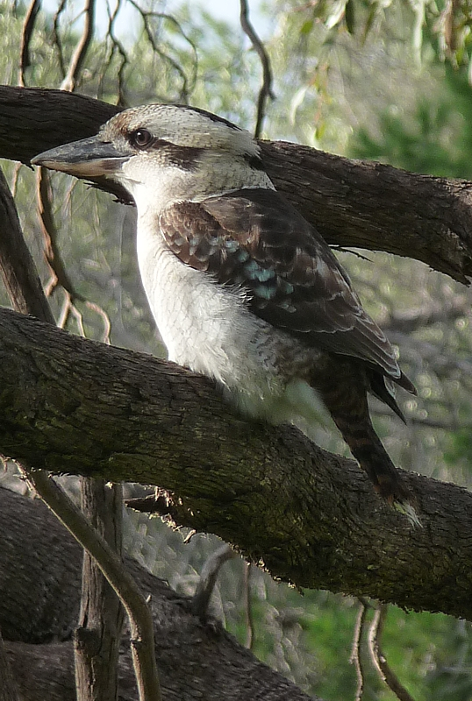

Volume 6 Number 3 June 2013

Title Page | 1 |  | Editorial, Disclaimer, & Privacy Act | 2
Message From Chairperson | 3 |  | Calendar – June to August 2013 | 4
Burnside Historical Society | 5 |  | Lochend & Locheil | 6
A. G. M. September | 7 |  | Important Notices | 8
Exploration of South Australia | 9 |  | No Dam Group News | 12
Olive Oil production | 13 |  | Mitcham in the past | 15
Food | 17 |  | Orkney and Bath | 19
Overland Escort Capt. Tolmer | 21 |  | Coinage, 1846 - 1852
End page | 24

OFFICE BEARERS FOR 2012

Patron: | Mr. Tim Oughton | Principal Scotch College
Chairperson Julie Hogan | Julie Hogan | Tel: 0430 472 262  45676676676676676676676
Vice Chairperson/Editor | Richard Irving | Tel: 8272 9707
Treasurer | Brian Angus
Secretary | Cheryl Schneider
Committee Members | Trish Cosh | Margaret White  K
 | Rowena Atkinson | Christine Edwards
 | John Wood

EDITORIAL
We have just come home after a journey through the United Kingdom and Ireland which opened for us so many pages in the history of the people who lived and worked there, we found it is literally all around the country. From the Neolithic complexes on Orkney, to the Roman Baths complex of Bath, through Ninth Century Edinburgh Castle and Eleventh Century Tower of London to but five minutes ago, the Islands are positively full to the brim with History!

While it was a wonderful experience to see so many spectacular examples of history dating from maybe as long ago as 3500 years, there are still pages of history waiting to be read where we are. Because we cannot match the United Kingdom and Ireland, that is certainly no reason to say we have no history worth anything.

All history, what ever the date associated with it, has merit, and is therefore worth researching to uncover the facts associated with it.

DISCLAIMER

Views and opinions expressed in articles in the Newsletter do not necessarily reflect the views of the Mitcham Historical Society Inc. While every effort is made to ensure the accuracy of articles printed, responsibility is not accepted for any errors they may contain that are out of the Society’s control.

THE PRIVACY ACT

A member’s personal information collected by the Society, for example name, address and telephone number, will only be used for forwarding of the Newsletter and relevant information concerning the Society. The information will not be shared, sold or given to any third party without the member’s consent. Any e-mails will be treated as above. However, any information sent by e-mail will be at the sender’s risk and the Society will not be held responsible for any unintended use or disclosure of this.

MESSAGE FROM CHAIRPERSON: JULIE HOGAN

Life has been hectic lately with a recent house move. What frustrates me the most is things that turn up after you have thrown the counter parts away or carefully packed and labelled items that mysteriously turn up incomplete. However, if you can be brutal and unsentimental, then it can be a good “fung shui” exercise. I myself, tend to be a bit of a hoarding softie and find it difficult to part with things. Due to the move, please note that my old home phone number is no longer relevant and my mobile remains the same. Our society’s events for 2013 commenced with our March Twilight Walk which was in the Kingswood area. Glen Woodward led us on a fascinating tour despite the extremely hot weather conditions. John Wood excelled with his April bus trip to Callington and Nairne which was fully booked as usual and highly successful. For May history month we focused on Brownhill Creek and Ellison’s Gully with our talk presentation at Scotch College and a follow up walk on the Saturday. Rick Irving has researched this topic over past years and due to an overseas trip was unable to be with us this year. My thanks to Ron Bellchambers and Andrew Tilley for sharing their extensive knowledge and offering up their services for these events. Unfortunately I was unable to confirm details for our July event as the Festival Theatre has been unable to accommodate our requirements. We may still be able to re-visit this proposed event at a later date. Please note our August event to the Campbelltown area. This is a unique opportunity to not only visit yet another historic house but also a modern sustainable housing development. Finally I would like to bring to everyone’s attention that Burnside Historical Society has invited any of our members who wish to attend to join them on Monday 17th June at 7.30pm, in the Coralie Soward Hall, Burnside Community Centre. Kate Walsh is presenting her topic: “Flower Power – George Smith, an Adelaide Landscape Gardener”. Parking is adjacent the Burnside Civic Centre (off Fisher Street, Tusmore).

Newsletter quotation:
“Things work out best for people who make the best of the way things work out” John Wooden
Calendar – June to August 2013

JUNE (Monday 3rd)
“Scottish Reflections”
Talk Presentation by Tim Oughton
Drawing Room, Scotch College at 7.30pm
Contact: Julie Hogan: 8338 3238 or 0430 472 262
Email: julie.a.hogan@gmail.com

JULY
Details to be advised
Contact: Julie Hogan: 0430 472 262
Email: julie.a.hogan@gmail.com

AUGUST (Sunday 11th)
Lochend House & Lochiel Park Tour at 2pm
View an historic house & an environmentally sustainable housing development
Contact: Julie Hogan: 0430 472 262
Email: julie.a.hogan@gmail.com



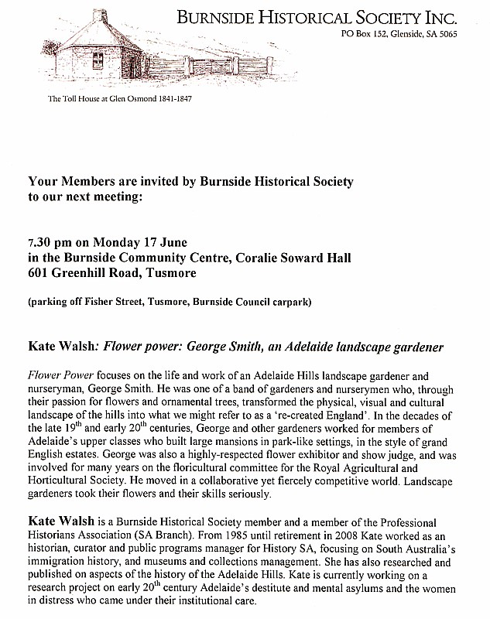

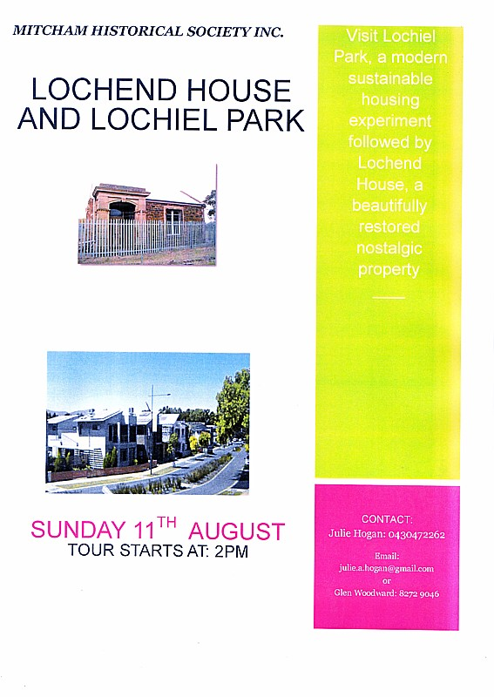

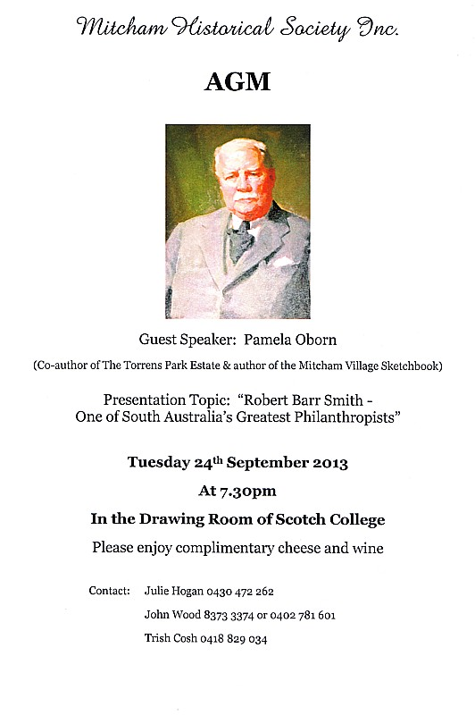

MITCHAM HISTORICAL SOCIETY INCORPORATION

NEW MEMBERS SINCE OUR PREVIOUS NEWSLETTER

We acknowledge and sincerely welcome Helen Pryor and our new corporate member, Richard Randall-Smith of Randall-Smith Interiors who have shown support to our Society by becoming members for 2013/14.

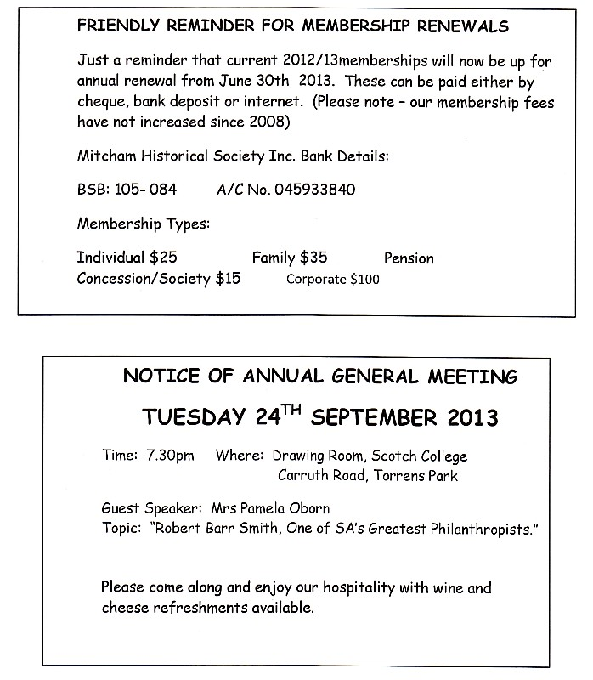
Exploration of South Australia.

Having begun to populate the Colony of South Australia, there were unanswered questions of what lay beyond their furthest vision, what was “over the hills and far away”? Exploration in the four cardinal points of the compass began very early in South Australia’s history.

The “South Australian” for Tuesday the sixth of June 1843 tells us that “Messrs Bunce and Barnard returned on Saturday. The Expedition did not penetrate much beyond Mount Arden, having found sufficient good country to the eastward of the Flinders-Range, which was previously discovered by Mr Burr. Besides, their farther discoveries were interrupted by a want of water, having been without that necessary for three days. The parties state that found in their travels some immense gums, measuring 24 feet in diameter, and saw some white kangaroos but we understand they did not succeed in capturing any of the latter. The rest of the party are expected today or tomorrow, and we shall give fuller particulars, if possible, in our next.” A later edition of the same newspaper mentioned that they had heard from a party recently returned from the north, that the Surveyor General's Expedition of Discovery had made good progress, having got to within a very short distance of Lake Torrens, on its eastern side. Mr Thomas, it is stated, had arrived at Mr. Hawker's station on his return from the expedition.

An expedition did not necessarily have to go hundreds and hundreds of kilometres, as this report shows.

“Wm. Giles, Esq., Manager of the South Australian Company, and a party of friends, who lately made an excursion to Lakes Albert and Alexandrina and the Courong, in order to examine the country, have just returned. They found the district fully to answer their highest expectations, being beautifully grassed, and the water excellent. Water of good quality is also to be got by digging six to eight feet. The peninsula between Lake Albert and the Courong is also abundantly grassed. In the centre of this peninsula there are a number of salt lagoons, which in summer become dry, when a thick incrustation of salt is left. There is a large lagoon on Mr Malcolm's property, in which the salt incrustation is about nine inches thick. The salt is of superior quality. The good country in the neighbourhood of the Lake amounts to 50,000 acres at least. The peninsula contains a large proportion of the above. Its contents in all are about 30 000 acres, and by putting a fence of about a mile in length it may be completely enclosed. So satisfied are the gentlemen with this fine district, that the South Australian Company are about to send down 8,000 sheep and about 800 head of cattle. Mr Henry Giles intends sending about 1,000 sheep, and Mr Davenport, acting under instructions from Neil Malcolm, Esq., of Poltalloch, is about to lay out a huge sum of money in the purchase of cattle, to be located there.

Other explorers, like Mr. Darke, went to Port Lincoln, which is “hundreds and hundreds” of kilometres from Adelaide.

“We congratulate the colonists, and especially the settlers at Port Lincoln, on the departure of the above expedition. We believe there are few men in these colonies so well qualified as Mr Darke to take charge of such an expedition, he having been, for many years, employed by the Government of Van Diemen’s Land, in the course of which he traversed the wildest parts of that country. By the active zeal of Mr Neales and other friends of the Port Lincoln district, Mr Darke’s party has been very completely equipped. As the objects of the expedition include, the exploration of a very wide extent of country, the knowledge of which will, doubtless, benefit the whole colony, we are anxious to see all classes contribute towards the expenses of the enterprise. These expenses, we understand, amount to about £ 150, of which, have been subscribed the same stated in the advertisement in another column. According to the old saying, we are all in one boat, and we hope that when a few of the citizens step forward so liberally to contribute for the public good, the rest will not be so selfish as to look coldly on. Many thanks are due to Captain Underwood, of the Governor Gawler, for giving the party and their equipment free passage and conveyance to Port Lincoln. We have no doubt his kindness will be remembered another day.” Another brief report mentions his departure from Port Lincoln. “Mr Darke and party left this settlement in high spirits on the 2nd instant. His first course will be N. N. West. He will visit Mount Wedge, and examine the country in that neighbourhood, and towards the coast. He will then go to the north.”

Another exploration of the north is reported in the “South Australian” for Friday the 6th of June, 1851. It states that“A new pastoral country has been discovered to the north of Mount Eyre, between latitudes 31º 50' and 31º. It is a mountainous country, and the ranges rise to the height of about 2000 feet. There are several streams, some of which are said to run the whole year. A well-known surveyor lately visited this country, with reference to a dispute, not yet decided, as to the right of run between Messrs Brown and Bagot. He describes a very singular locality - a piece of level land capable of depasturing 500 head of cattle, surrounded by perpendicular rocks which rise to the height of 1000 feet, and there is only one point of ingress or egress, a narrow swampy gorge, which cattle would not willingly pass. It has been named the Pound. Mr C. N. Bagot claims the honor of discovering this new country, which extends about 150 square miles. It is to the eastward of Mr Eyre's track from Mount Eyre to the Two Peaks, and is the farthest available country in the direction of Mount Hopeless. From the hills a good view was obtained of Lake Torrens which was seen distinctly trending away to the westward as far as the eye could reach.


The Stormwater Management Authority (SMA) approved the catchment councils’ 2012 Brown Hill Keswick Creek Stormwater Management Plan at their February 26th meeting. This decision to approve the $150million plan, meant that the vast bulk of the project works could proceed in Part A of the plan, representing $120million or 80% of the project. Part A contains all works in the Keswick Creek catchment and Lower Brownhill Creek catchment. Part B works, in the Upper Brownhill Creek catchment above Forestville Reserve, were given an additional 12 months for further investigation, until March 2014. Part B works include an upgrade of the Brownhill Creek channel, the Malcolm Street (Millswood) to Glenelg Tramway bypass culvert and the proposed dam or no dam option. A reminder that the feasible No Dam Option 3A is now one of the Recommended Stormwater Management Strategies in the 2012 plan and requires some additional channel works and one additional bypass culvert (not in the streets of Unley). It is also worth a reminder that 5,270 metres of bypass / diversion culverts will be constructed in the Unley area, with or without a dam. A table of Recommended Stormwater Management Strategies and a map of Structural Works Components, from the 2012 plan, is available on our website www.brownhillcreek.org in Get The Facts, under Our Case.
After supporting Part A works, West Torrens Council are now investigating possible alterations to the works in the Keswick Creek catchment. The implications of these potential changes will be reported on in later updates. It now seems clear, thanks to an independent study by the Snowy Mountains Engineering Corporation (SMEC), that the cost and impact of the proposed dam in Brownhill Creek Recreation Park / Wirraparinga, will be much greater than first thought. Please check Mitcham Council’s website www.mitchamcouncil.sa.gov.au for full details of this report.

Eucalyptus Oil.

In describing some exhibits in the 1887 Exhibition writes, “But the principal exhibit in the case and one that will have universal interest for South Australians is to be seen in a number of cylindrical bottles of South Australian eucalyptus oil of the firm's own manufacture. After much practical work and research with all the skill and appliances at their command the firm have succeeded in producing eucalyptus oil of a quality pronounced by experts from the other colonies superior to any they have yet seen. The manufacturers having at length, after much difficulty, found a piece of country on which the most suitable kind of eucalyptus is growing, are carrying out their plans for its production on a large scale, and all will agree in hoping that the demand will justify the enterprise and intelligence which have led Messrs. Faulding & Co. to establish this new industry in South Australia.”

Establish a new industry is exactly what they did, and the challenge was accepted by the firm of Woods & Company, who opened a factory on Kangaroo Island.

Where is there an Australian who cannot find a word of praise for eucalyptus oil? The more this health promoting elixir is used the more numerous have its virtues proved to be. If in Australia it is regarded as a necessity, what a future should there be for it in older, colder, and perhaps dirtier countries! What a boon a few drops of the oil on a handkerchief would be to thousands of sufferers from asthma and other lung complaints in the trying November fogs of the United Kingdom! Australia, for the sake of those who would bless such a comfort, as well as for commercial reasons, should see that eucalyptus oil is in the front rank of her industrial exports. That there is room for expansion in the manufacturing no one will doubt. The public will therefore welcome the advent of the firm of Woods and Co., who have just started a factory within five miles of Queenscliffe, Kangaroo Island, for distilling and refining the essential oil or eucalyptol from the small-leaved trees which are specially approved for the purpose, and which grow on the island in immense numbers. The firm have started work energetically, looking forward to doing a large trade. They have a depot at Port Adelaide, to which the extract is forwarded in 10-gallon tanks to be bottled and cased. Shipments will be made to London in bulk, the firm trusting to the excellent quality of the oil and its cheapness ensuring for it early popularity. The brand adopted is a picture of a lubra with a baby on her back, and waving a sprig of eucalyptus in her hand.

Messrs. Woods & Co. have just established a factory some fire miles from Queenscliffe. Kangaroo Island, for the manufacture of eucalyptus extract, or essential oil of eucalyptus highly rectified. The firm intend manufacturing the oil in large quantities, and, with this end in view, have sunk a large amount of capital in the venture. A site was selected for the distillery near Queenscliffe so as to be within easy distance of the small-leaved trees which are especially valuable for the production of oil, and which grow on Kangaroo Island in large numbers. A commodious factory has been erected, and with the expansion of trade —the firm intend pushing the sale of the oil in the United Kingdom—which is looked forward to with confidence it is expected that employment will be given to a large number of hands who will be engaged in a purely local industry. A depot has been opened at Port Adelaide, and the oil will be shipped from the island in bulk to the Port. Here it will be re moved from the 10 gallon tanks in which it crosses the gulf, and will be bonded, labelled, and packed by girls employed for the purpose. The brand adopted by the new firm is a representation of lubra having a piccaninny slung on her back, and carrying a sprig of eucalyptus in her hand. This device has been registered in the colonies, Great Britain, and the United States.

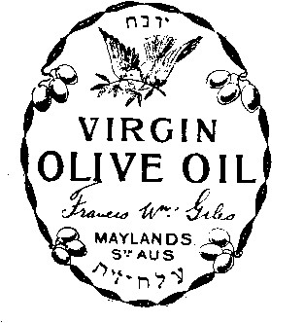
MITCHAM TRAM SERVICE.

The first step towards electrifying the Mitcham tramway will be taken to-day, when the permanent way contractors will begin the work of taking up the metals between Cross Roads. Malvern, and the Mitcham terminus, and relaying heavier ones for the electric cars. A large gang of men will be employed in the construction of the line, and the work will be accomplished as quickly as possible. The Mitcham line will be the first of the outer areas system to be opened. Whilst operations are proceeding the service will be maintained by buses.
(The Advertiser, Wednesday 31 August 1910, page 10)

Do this sound at all familiar? A sign of things to come?

ELECTRIC TRAMS.
To the Editor.

Sir It is more than 13 years since electric trams were established in Hobart, leaving only one place of any consequence (New Town) without them. The only other suburb unconnected with trams is Sandy Bay. Hobart has a much smaller population than Adelaide. Hobart has been designated as "Sleepy Hollow." What should Adelaide be christened?

I am, &c,
R. P. BROOKE.
January 15, 1904.
(The Advertiser, January 16th 1904, page 9)

MITCHAM.

Mitcham, one of the earliest settled of the Adelaide suburbs, was among the first to establish tram communication with the city, and though frequently spoken of as a "sleepy hollow," the result of Saturday’s poll proves that the residents are, as of old, anxious to have available as soon, as possible, the most up to date means of travelling to and from the metropolis. In the outlying wards not touched by the tramways very little interest was taken in the poll, but in the Mitcham and Goodwood wards the feeling was very strong. The totals for the district show that the voting was nearly three to one in favour of the adoption of the Snow scheme. The returning-officer (Mr. W. Bradey) and his assistants discharged their duties in a very able and pleasant manner, and there was not the slightest hitch.

Wards.

On roll. Yes. No. Infl.

Mitcham... 550 189 6O 3
Goodwood .. 425 103 50 1
Glen Osmond .... 53 11 6 -
Upper Sturt. 121 17 2 -
Coromandel. 153 22 2 -

1,303 342 120 4

(The Advertiser, Monday 10 February 1902, page 6)

MITCHAM PUBLIC SCHOOL.

The annual entertainment given by the scholars of this school was held in the institute. The Premier (the Hon. T. Price) presided over a large attendance. The programme consisted of part songs, character and action songs, physical exercises, and recitations. The items were well rendered, and met with the hearty approval of the audience. The same programme was repeated on Wednesday evening at the St. Columba's Hall, Hawthorn, when there was again a good attendance, and the children acquitted themselves well. The proceeds of the two evenings will be a substantial addition to the school fund.
(The Advertiser, August 24th 1907, page 11)

PACKING BUTTER

The increased price butter in autumn, as well as its scarcity in winter, renders the best mode of packing it a matter of some importance. There are several particulars of minor importance to be attended to, to which greater or less attention is given by good butter makers; but the two leading requisites, without which there must be a failure, and with which there cannot easily be, are clean vessels and thorough working. The importance of the former in obtaining perfectly sweet butter must be evident to every one, hence the necessity of washing vessels by scalding; and when they become rusty from disuse, of employing chloride of lime. In order to keep the sweetness, it is indispensably necessary that every particle of buttermilk be worked out before packing down. This is ascertained when it ceases to flow from it. Inexperienced butter makers perform this part of the operation very imperfectly. Work the butter four times as long as you think necessary, and then perhaps you will have half completed it. When it is thoroughly worked, pack it down by beating, in a strong pot, cover the top with an inch of very strong brine, and keep it in the coolest part of the cellar, and you need not fear its becoming injured before next winter.
(Southern Australian, Tuesday 11 July 1843, page 3)

Visit of Agricultural Students to Bankside

Through the courtesy of Messrs. Hardy and Sons the pupils of the Agricultural School paid a visit to the Bankside Vineyards on Thursday afternoon. Some 40 odd pupils accompanied the head teacher (Mr. Ferguson) and Mr. Hassler, the assistant, left Adelaide by the Thebarton car, arriving at Bankside at 1 o'clock. Here they were met by Mr. Hardy,and were shown over the vineyard. Demonstrations in the different methods of pruning were given by Mr. Hardy and his workmen. A number of pupils, under the guidance of the pruner, were then given an opportunity of
trying their skill, and showed very fair knowledge. Mr. Hardy then conducted the lads to the workshops, where the men were at work making casks, vats, &c. Great interest was taken in this particular work. The olive oil making was in full swing; and the different processes in the manufacture of the oil were carefully explained. After sampling some of the choicest raisins made on the premises three hearty cheers were given for the managers and workmen, and the lads returned to town highly pleased with what the saw.
(The Advertiser, Friday 10 June 1898, page 7)

THE COUNTRY.

0NI0N-GR0WING IN THE SOUTH - EAST.

MOUNT GAMBIER. July 14.
It is estimated that 350 to 360 acres of land here will be devoted to onion growing in the coming season, as against about 220 acres last year. The increase will be mainly due to the enterprise of the Messrs Webster, who are putting in over 300 acres, or an increase of about 140 acres. Messrs Charlick Brothers are planting 9 acres at Yahl, Mr. Halliday 12 acres in the same locality, and Mr. F Knight 6 or 9 acres at Mount Gambier. Several other growers are putting plots of an acre or less each under the bulb. Last season the onion crop, owing to the winds and grubs, was a disappointing one. The Messrs Webster estimate their loss at 200 tons, and some smaller growers lost practically the whole of their crops. In one field of 50 acres the Messrs. Webster pulled 7 tons per acre, but the crop was saved from the grubs— or, rather, the grubs - were removed from the crop—by hundreds of magpies, which lived on the pests for weeks, and later on by a multitude of boys that the growers employed to gather the grubs. In the brewery paddock, at the railway entrance to the town, the crop in which two seasons ago to astonished and delighted visitors, but which last season was greatly damaged by the wind, Messrs. Webster have town narrow strips of rye at intervals of two or two and a half chains, across the course of the west wind, to prevent the plants being blown out of the ground.

(South Australian Register, 18th July 1899, page 3.)
Orkney

The Orkney Islands, situated only a few miles off the northern coast of Scotland, are definitely a must to see for anyone interested in Neolithic life. These sites are World Heritage, and deservedly so. Thanks to “The Islander 2013” a free newspaper for visitors to Orkney, information on some of these sites can be included in this article.

One of the monuments most easily seen is the Ring of Brodgar, which stands on an eastward sloping plateau on the Ness of Brodgar, and is generally thought to have been erected between 2500 and 2000 BC. The stone ring was built as a true circle, 104 metres wide, and it is thought to have originally contained 60 megaliths. Today, only 27 remain. The Brodgar ring is the third largest stone circle in the British Isles.

On the southern shore of the Bay of Skaill in Sandwick is the Neolithic village of Skara Brae — one of Orkney’s most visited historical sites and rightly regarded as one of the most remarkable monuments in Europe. In the winter of 1850, a great storm battered Orkney. There was nothing particularly unusual about that but, on this occasion, the combination of wind and extremely high tides stripped the grass from a large mound then known as “Skerrabra”. This revealed the outline of a series of stone buildings that intrigued the local laird, William Watt of Skaill, who began an excavation of the site. Today, Skerrabra, (or Skara Brae, as it has become more commonly known) is made up of eight Stone Age dwellings, linked by a series of low alleyways. Because of the protection offered by the sand that cocooned the settlement for 4,000 years, these buildings and their contents are incredibly well—preserved, with the walls of the huts still standing, and alleyways still roofed with their original stone slabs.

In Lamb Holm can be seen the Italian Chapel, a beautiful Roman Catholic chapel, which was constructed by Italian Prisoners during the Second World War. It is not only one of the most well-known and famous sites in Orkney, but also a beautiful place of worship and a marvellous testimony to the craftsmanship and resourcefulness of the men who built it, Italian Domenico Chiocchetti and his fellow prisoners or war.

These examples are only a brief representation of the true extent of Orkney history, ranging in age from around 70 years old (The Italian Chapel) to close to 4000 years (Maeshowe). Others include Tomb of the Eagles, Banks Tomb, The Knap of Howar, and Barnhouse Settlement.

The City of Bath

The Roman invasion of Britain was a very significant event in the history of the British Isles, and the date that Julius Caesar set foot on British soil probably known to many, being 55 BC. In Bath, the Romans built a magnificent temple and bathing complex, around Britain's only hot spring, which brought over one million litres of hot water to the surface every day at a temperature of about 48 degrees centigrade.

Around this complex, there quickly grew a town, Bath. First discovered, or in truth, re-discovered, in the nineteenth century, the Roman Baths are one of the best preserved ancient Roman sites in the UK and form a major tourist attraction.

It has been suggested that there may have been human activity in the vicinity of the Roman Baths for the past 8000 years, but it is the Roman activity that excavations produced, and it is a part of the history of the United Kingdom that should rate in the top ten sites, along with Stonehenge, Skara Brae and the Tower of London.

OVERLAND ESCORT.
08 07 52

The Gold Escort have we think, done their work in a style which must command universal admiration and the gratitude of this community. They accomplished the journey to Forest Creek in 19 days, and having left on the 14th ultimo, the return was effected in 22 days, which considering the season and the dreadful country, is an astonishing performance. The cart conveying the gold was lost in Deep Creek, 20 miles west of Forest Creek, and the gold had to he made up in packs and carried on horseback. For days the men bad to travel on foot up to the knees in water, and having no tents, nothing more comfortless can be conceived. Fortunately the party kept their health, and no farther accident occurred. But the men suffered severe loss by the tear and wear of the clothes: and having to pay the exorbitant prices for necessities at the diggings, we consider they are very badly remunerated for their exertions and hardships. We hear that the force have petitioned for an increase of pay, and we are sure every colonist will heartily rejoice if they receive it. The pay for the police generally, especially in these dear times, is far too little, and with regard to the Overland Escort treble pay and rations would not be too much for such a service.

(Adelaide Morning Chronicle, Thursday 8 July 1852, page 3)

THE OVERLAND ESCORT.
12 07 52

We regret to learn that James Grimsdick and William Benson, two of the mounted Escort, on being required by Mr Tolmer to accompany inspector Alford back to the diggings, absolutely refused to go. Mr Tolmer very properly put them under arrest, and, in terms of the Police Act, committed them to gaol with hard labor for a month. We advocate justice to the men engaged in this arduous service, which we think entitles them to increased pay, but at the same time it is clear that if it is left to the option of the men to obey orders or not, as may suit them, it would be folly to continue the Overland Escort. Inspector Alford's party may be expected about the end of this month. Inspector Stuart will conduct the next party overland, and will probably leave in a few days.

(Adelaide Morning Chronicle, Monday 12 July 1852, page 3)

THE ESCORTS.
22 07 52

The Escort for the diggings is under orders to march this morning at 11, and will take a mail. It is probable, however the party may be detained for a few hours. It will be under the command of Inspector Stuart. Inspector Alford's party may be expected about 18 days hence.

(Adelaide Morning Chronicle, Thursday 22 July 1852, page 3)

COINAGE

SCARCITY OF COPPER COINAGE IN SOUTH AUSTRALIA
05 12 46

Gentlemen—Notwithstanding copper is so plentiful, yet one of the nuisances to the shopkeepers and others is the want of pence. In one instance, I know for a fact that one pound, two and sixpence was offered and refused for twenty shillings worth of coppers. The party referred to says he loses considerable sums in twopences and threepences.

A public nuisance is caused also by this sad want of “change." At the Post Office, parties must go prepared with coppers, or if the postage comes to a few pence more than silver, unless they have coppers they must leave their letters unposted to get the needful, and perhaps miss the post.

Now the remedy is so simple and practicable as to induce me to imagine it will be adopted. I would recommend either the issuing of copper coins by the Commissariat, or the circulation of penny postage stamps, as in England.

I merely throw out the hint, hoping that something may be done speedily.
Yours, &c, W.

(South Australian Register, Saturday 5 December 1846, page 3)

Coinage 31 03 48

A silver coin, of the value of two shillings, was to be issued from the Mint in about February or March. The new five-shilling piece, issued many months ago, has not, so far as we are aware, been received in the colony. We saw an engraving of it some time back. It is very handsome. The Queen is represented with the crown on her head: the inscriptions are in the Old English character, and the arms on the reverse, instead of being quartered, are borne on four shields placed crosswise-two containing those of England, and the others those of Ireland and Scotland.

(South Australian, Friday 31 March 1848, page 3)

THE NEW COINAGE
09 08 52

We are thunderstruck to hear that the Government, notwithstanding their express engagement, are hesitating about establishing a Mint. Surely the experience of California, where 15 mints were established by private parties and proved profitable, is sufficient to demonstrate that one in South Australia is a safe speculation; and now that the Home Government have positively sanctioned the institution of Mints, it would be disgraceful if this colony were to flinch from an enterprise which must prove beneficial to the whole of the Australian colonies, and eminently lucrative to our colonists. We shall return to the subject in our next.

(Adelaide Morning Chronicle, Monday 9 August 1852, page 2)

CORPORATE MEMBER LOGOS

It is with pleasure that we present here the Business Logos of our Corporate Members, namely:
The Edinburgh Hotel & Cellars Adelaide Expo Hire Scotch College
Mitcham Antique Gallery Dowling City Country Mitcham Square Newsagency









POSTAGE
PAID
AUSTRALIA
PRINT
POST
PP 536729/00025
If undeliverable return to:
Mitcham Historical Society Inc.
PO Box 903 Mitcham Shopping Centre
S. A. 5062
Mitcham Memories
Print Post Approved
PP 123456/12234

Address Label

? Southern Australian, Tuesday 6 June 1843, page 2
? Southern Australian, Tuesday 1 August 1843, page 2
? Southern Australian, Tuesday 19 September 1843, page 2
? Southern Australian, Tuesday 20 August 1844, page 3
? Southern Australian, Tuesday 10 September 1844, page 2
? South Australian, Friday 6 June 1851, page 2
South Australian Register, Thursday 7 July 1887, page 1
South Australian Register, Saturday 3 December 1892, page 5
? The Advertiser, Tuesday 13 December 1892, page 5
? Islander 2013, page 17, 18.
? Islander 2013, page 16.

