The MITCHAM HISTORIcal society
IncORPORATED NEWSLETTER

POSTAL ADDRESS: PO Box 903 Mitcham Shopping Centre S. A. 5062

Web Site: http://www.mitchamhistoricalsociety.org.au/bgHistory.htm

Mitcham Memories
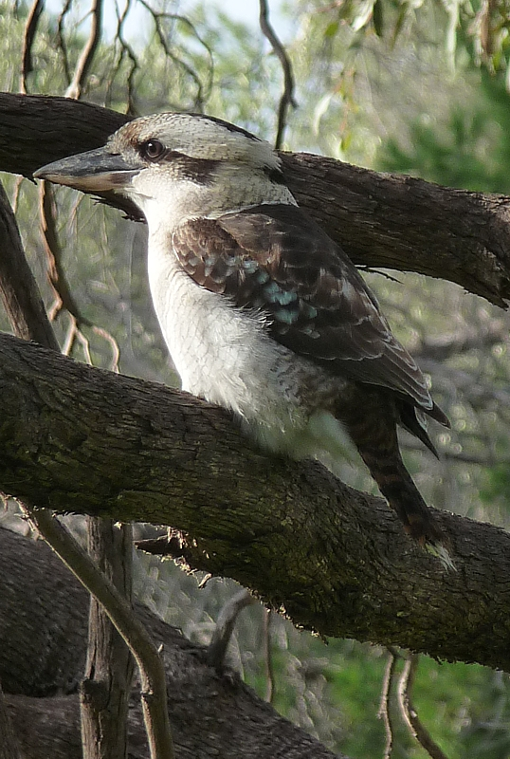

Volume 6 Number 2 March 2013

Title Page | 1 |  | Editorial, Disclaimer, & Privacy Act | 2
Chairperson’s Report | 3 |  | Calendar for 2013 | 4
Calendar for 2013 | 5 |  | Kingswood Twilight Walk | 6
Callington Mine Tour | 7 |  | History Week Flier One | 8
History Week Flier Two | 9 |  | June Presentation at Scotch | 10
No Dam Group News | 11 |  | Lost Gardens of Mitcham | 12
The Mitcham Flour Mill | 15 |  | The Walloway Railway Disaster | 17
State Library: WOW factor | 20 |  | Lawrence D Boorman | 21
William Ashley Norman | 22 |  | Charles R Sutton | 23
End page | 24

OFFICE BEARERS FOR 2012

Patron: | Mr.Tim Oughton | Principal Scotch College
Chairperson Julie Hogan | Julie Hogan | Tel: 0430 472 262 or 8338 3238 45676676676676676676676
Vice Chairperson/Editor | Richard Irving | Tel: 8272 9707
Treasurer | Brian Angus
Secretary | Cheryl Schneider
Committee Members | Trish Cosh | Margaret White  K
 | Rowena Atkinson | Christine Edwards
 | John Wood

EDITORIAL

Opening Doors

Years ago, there used to be a song called “Green Door”, and the opening lyrics asked what was behind it. Whatever was behind that door, is now history. To find out what is behind any door, just open it! There are many doors awaiting opening, behind which there are interesting historical facts, as I have found out. Take the history of the Mitcham Flour Mill. Thanks to another Mitcham Historical society member, I was aware of its existence in Mitcham many years ago. One door had been opened, but others awaited me. Recently, I was lucky enough to find the key to another door within the history of Mitcham’s Mill. It was by a fire that its existence became known to me. Somewhere in the Brownhill Creek Hills (in metaphorical terms) there is another door waiting to be opened. Somewhere up there, an old brewery existed. Metaphorically speaking, almost wherever we go, there is at least one door awaiting opening, awaiting our interest in it to find the key and open the door, and learn about the history behind it. What lies behind the “Green Door”?
DISCLAIMER

Views and opinions expressed in articles in the Newsletter do not necessarily reflect the views of the Mitcham Historical Society Inc. While every effort is made to ensure the accuracy of articles printed, responsibility is not accepted for any errors they may contain that are out of the Society’s control.

THE PRIVACY ACT

A member’s personal information collected by the Society, for example name, address and telephone number, will only be used for forwarding of the Newsletter and relevant information concerning the Society. The information will not be shared, sold or given to any third party without the member’s consent. Any e-mails will be treated as above. However, any information sent by e-mail will be at the sender’s risk and the Society will not be held responsible for any unintended use or disclosure of this.
MESSAGE FROM CHAIRPERSON: JULIE HOGAN

Welcome back everyone and I hope you all had a great Christmas Break.
2012 had started with a couple of family medical emergencies so thankfully 2013 has begun with no such dramas! We celebrated New Year ’s Eve in the busy Penneshaw Hotel on K.I. and this was one of the few occasions, Colin and I actually saw the new year in. (Usually we are asleep at that time of the night!) However the pub band was playing old rock’n’roll numbers which kept us entertained throughout the evening. Now it is back to business on the mainland with planning our 2013 programme. First up we have our Kingswood Twilight Walk on Tuesday 12th March at 6pm. Details are on the newsletter flyer and we will be guided by our Number One Guide, Glen Woodward so I am sure it will be an entertaining event. John Wood is finalising details for the April bus trip to the Callington area, so be sure to book in early for that event if you are interested as the bus tends to fill up fast. For the About Time S.A. History Festival activities in May, we will be focusing on Brownhill Creek. On Wednesday 8th of May we will be having a talk presentation with Andrew Tilley and Ron Bellchambers on the history of Brownhill Creek at Scotch College. Andrew Tilley will also host a walk on Saturday 11th of May through Ellison’s Gully. In early June we will be having a presentation by Tim Oughton, Principal of Scotch College on his recent school exchange experience in Scotland. (In a way you could think of this event as a different kind of “Scotch at Scotch”.) We will be visiting the Campbelltown area in August where we will look at an historic house and an innovative sustainable housing development. Later in the year we will visit the Glen Osmond area and there will be a bus trip to the Barossa region. I hope members can find something of interest for them to attend and I shall leave you with this thought.
“Be thankful for what you have and you will end up having more. But if you concentrate on what you don’t have, you will never ever have enough.” Oprah Winfrey

PROGRAMME FOR 2013

MARCH (Tuesday 12th)
Twilight Walking Tour – Kingswood
Time: 6pm to 8pm
Hosted by Glen Woodward
Meet at the community car park
(behind the Shell Petrol Station)
Cost: Gold coin
Contact: Julie Hogan: 8338 3238 or 0430 472 262
Email: julie.a.hogan@gmail.com

APRIL (Sunday 14th)
Callington Heritage Mine Trail Tour
View early mines around Callington and distinctive landscapes
around the Bremer River
Time: 9.30am
Bus departs from Mitcham Council Car Park
$75.00 for members & $85 for non members
Limited seats so book early to avoid disappointment
Contact: John Wood: 8373 3374 or 0402 781 601
Email: johnwood@adam.com.au
Julie Hogan: 8338 3238 or 0430 472 262

MAY
About Time SA’s History Festival Activities

Brownhill Creek Presentation (Wednesday 8th)
Drawing Room, Scotch College at 7.30pm

Brownhill Creek/Ellison’s Gully Walk (Saturday 11th)
Meet at the Manure Pits at 1.30pm sharp

Contact: Julie Hogan: 8338 3238 or 0430 472 262
Email: julie.a.hogan@gmail.com

JUNE (Monday 3rd)
“Scottish Reflections”
Talk Presentation by Tim Oughton
Drawing Room, Scotch College at 7.30pm
Contact: Julie Hogan: 8338 3238 or 0430 472 262
Email: julie.a.hogan@gmail.com

JULY
Details to be advised
Contact: Julie Hogan: 0430 472 262
Email: julie.a.hogan@gmail.com

AUGUST (Sunday 11th)
Lochend House & Lochiel Park Tour at 2pm
View an historic house & an environmentally sustainable housing development
Contact: Julie Hogan: 0430 472 262
Email: julie.a.hogan@gmail.com

SEPTEMBER (Tuesday 24th)
AGM
Time: 7.30pm
Drawing Room, Scotch College
Contact: Committee Members

OCTOBER
Proposed “Investigating Barossa Wine Families” Trip
Details to be advised
Bus departs from Mitcham Council Car Park
Contact: John Wood: 8373 3374 or 0402 781 601
Email: johnwood@adam.com.au
Julie Hogan: 0430 472 262

NOVEMBER
Proposed Glen Osmond Tour
Details to be advised

DECEMBER (Tuesday 10th)
Christmas Breakup Function at Edinburgh Hotel
Time: 4pm
Contact: Committee Members

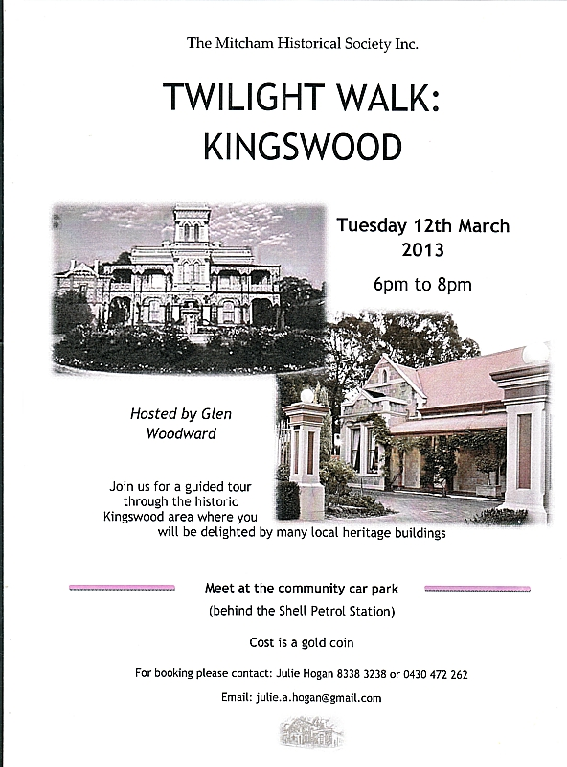

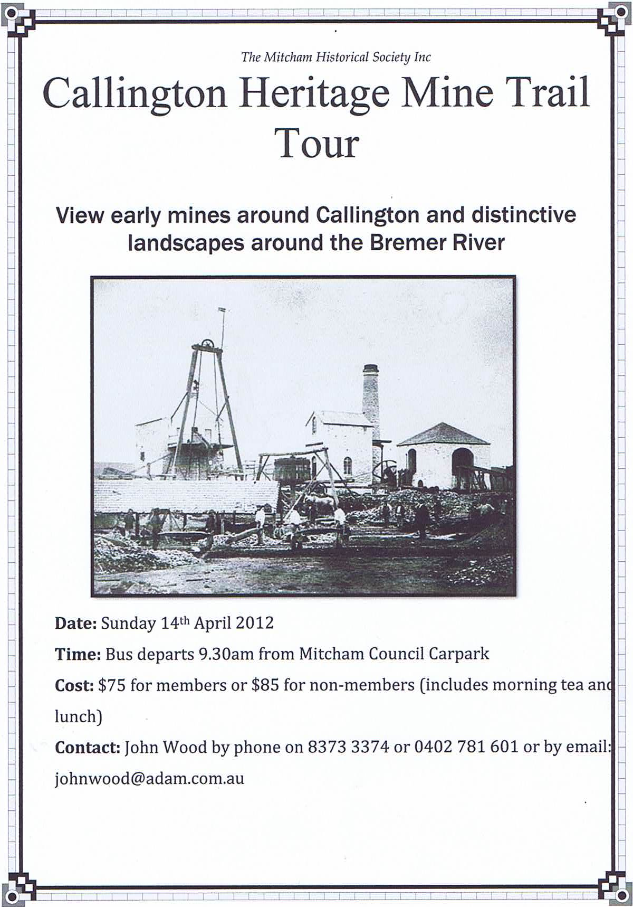
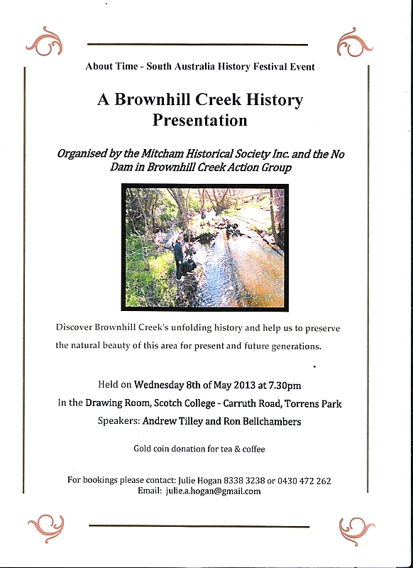
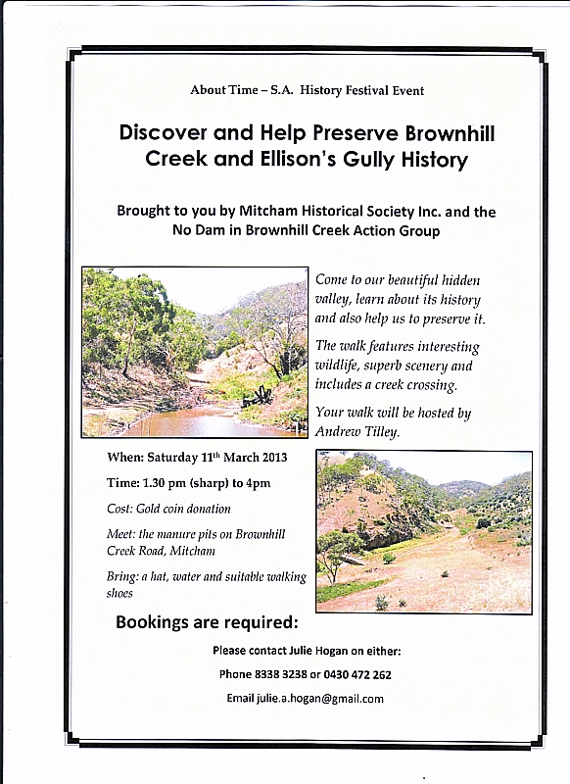

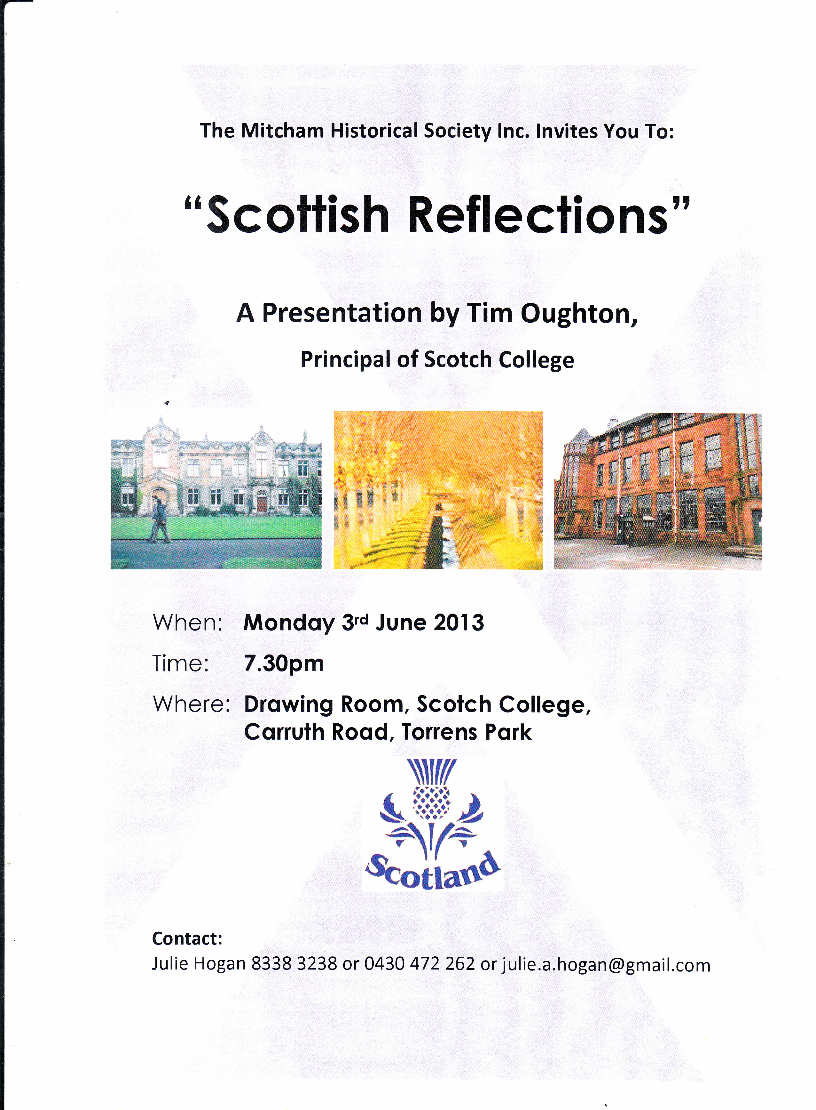



An article about the iconic Stone Pines at “Seven Pines” has been published in Trust News Australia: Volume 6, No 1 February 2013. The National Trust magazine has a large circulation Australia wide and support to protect this heritage site is growing. You can read the article on our website at www.brownhillcreek.org in the News section, along with the full Stone Pines report.
Charlie Buttigieg, Tree Nominator to the Register of Significant Trees of the National Trust of Australia (Victoria and South Australia), states that; “The Brownhill Creek Stone Pines are undoubtedly Living Monuments of great historical significance for Mitcham and the State of South Australia. They also have botanical and scientific significance at National and International levels. Their nomination to the Register of Significant Trees of the National Trust of Australia accounts them new status”.
The new Stormwater Management Board is likely to vote on the 2012 Stormwater Management Plan at their February 26th meeting. Reports on the proposed dam and urban Brownhill Creek channel capacity issues, are due this month. The outcome may well generate a dramatic News Page.
Mitcham Historical Society’s generous donations will guarantee a strong No Dam campaign in 2013. We have already started using these funds to upgrade our website and to develop educational resources that will be used by our community for many years. Hopefully this campaign will raise the profile of Mitcham’s precious environment and heritage and the role of the Mitcham Historical Society. Interestingly, the State Library of South Australia in partnership with the National Library of Australia, wish to archive our website, so that it becomes part of the documentary heritage of our nation. History in the making!

Lost Gardens of Mitcham

For the purposes of this article, the “Lost Gardens of Mitcham” are collectively taken to mean the well-groomed, well-organized and attractively presented gardens of the larger stately homes of Mitcham, during the years 1860 to 1910.

Apart from Birksgate, a list of the stately homes and mansions of Mitcham would have included Claremont, Corega, Delamere, Eynesbury House, Helenholm, Monalta, Netherby, The Glen, The Rosary, Springfield House, Torrens Park, and Urrbrae House.

In Preiss & Oborn’s book, The Torrens Park Estate, there is a photograph of a painting of the gardens Eynesbury house which shows but one of Mitcham’s lost gardens. There was a time when the gardens of Eynesbury, the spectacular three-storey Italianate mansion at Kingswood, stretched over 1O hectares. Set in grounds that are huge by today’s standards, the stately pile still looms over the suburb. But it is a shadow of its former glory. The grand garden that once went with it has long been subsumed into the neighbourhood, like so many that must have existed throughout Mitcham.

Preiss & Oborn include a detailed chapter on the garden of Torrens House, and how Robert Barr-Smith sourced the plants for it, and his instructions to Evans, his gardener. They point out that “Whilst overseas Barr Smith bought a large assortment of bulbs and cuttings including roses, carnations, cyclamens, begonias, hyacinths, pelargoniums, eucharis, chrysanthemums and irises. While all the correspondence to his suppliers, to Evans his head gardener, and to his steward Bruister, is faithfully, if at times illegibly, preserved in his letterbooks, virtually nothing else remains of this buying spree, which must have resulted in a blossoming at Torrens Park.”

The Mail for Saturday 11 August 1928, speaking of “The Glen”, on page 13, mentions that “The grounds were planted by Mr. Montefiore with rare and choice imported trees and shrubs, some of which still exist.”, and “Garden parties were given, and a feature of much interest was the glorious wistaria which completely covered the verandah on three sides of the house.”

The resources mention blossoming, glorious gardens in the period 1860 to 1910, and they both point out that “virtually nothing remains” of them. I believe that it is quite a reasonable supposition to assume that most of the stately homes mentioned above would have had beautiful gardens. These, then, are the “lost gardens of Mitcham.”

There is little or no doubt that during the Victorian Era, the plants in the gardens of Mitcham, like the rest of Adelaide, were of conspicuous excellence and beauty. Reports of Flower and Garden Shows speak highly of both the quality of the flowers and also of their many different popular types.

The South Australian Register for Friday 25th of September 1863, on page 2 states, in part “Of the floral department we are able to speak generally in terms of commendation. The cinerarias were conspicuously excellent, and the plants growing for the most part in bloom presented a very handsome aspect. The show of cut flowers was also very good. Roses of almost every variety and shade of colour were there, and the number of sparaxes was very large. We noticed also some very fine hyacinths, pansies, verbenas, anemones, and gladioluses. There was likewise a very good show of ranunculuses, both with respect to number and quality.”

More of the same can be read from The South Australian Advertiser for Friday 19th September 1873, on page 2, which says “One pleasing feature, was the pretty and extensive display of cottage garden geraniums, which were superior, as a whole, to those exhibited by professional cultivators. The basket, hand, and button-hole bouquets were beautiful, and well repaid inspection. The tasteful choice of flowers and arrangement of colors they indicated calling forth great admiration. In other flowers, pelargonium and anemones attracted much attention. The gloxinias were very choice, and, for shape and size, have never been surpassed in the colony. The cinerarias were exceedingly fine; and a Victor fuchsia attracted much notice on account of its splendid bloom and rich and distinct foliage.”

Both the South Australian Weekly Chronicle for Saturday 15th of September 1883, on page 22, and the South Australian Chronicle, for Saturday 28th of November 1891, on page 23 speak highly on such descriptions as “gratifying excellence, choicest blooms, an appearance of wonderful attractiveness, most perfectly shaped and all that could be desired.” Also used are the phrases “remarkably good, high quality, wonderfully fine, noteworthy and truly charming”

These reports also have given us an insight into what sorts of flowers were available to the gardeners of Mitcham for planting. One newspaper report mentions that “It is gratifying to mark that the foxglove has taken its proper place in suburban gardens during the past few years. There are not many plants which produce flowers more truly charming than its pendant bells.”

Both the above paragraphs speak of the underlying care and attention to detail given, the gardens being labours of love, things that were highly respected and prized by their owners. It would surely have been a delight to see them, wherever they were situated. If flowers could be judged so highly at these flower shows, it follows that they had to be grown in the suburbs, which of course included Mitcham’s lost gardens.

Discussing the voyages of Matthew Flinders, on page 10, The Advertiser for Saturday 25th July 1903, states “How astonished the intrepid commander would be if he could revisit the scene of his explorations. In the Great Lone Land, whose coast he for the first time surveyed, he would find beautiful flower gardens, large orchards and vineyards.”

Revisiting between 1860 and 1910, he would have found “beautiful flower gardens.”

*** ** ***

The Mitcham Flour Mill

Mitcham had a flour mill, situated on Victoria Terrace, from possibly as early as 1931 to at least December 1941. On page 18 of the Chronicle for Thursday 2nd December 1937, there is a report of a fire at Mitcham, which stated:- “Damage estimated at between £4,000 and £4,500 was done by a fire which destroyed the building and contents of the Mitcham Mill, Victoria terrace, Lower Mitcham, early on Sunday morning. It is thought that the fire was probably caused by an electrical fuse or short circuit during the severe storm earlier in the night. Flames were leaping 200 ft. high when the Metropolitan and Unley Fire Brigades arrived, and more than 1,000 people, awakened by the glare and the crash of falling timber and iron, saw the building collapse. The large iron roof of the mill fell in soon before the arrival of the firemen, who concentrated their efforts on saving a large newly built shed adjoining the building on one side and the betting shop of Mr. E. C. Fraser, of Lower Mitcham on the other. Next to the betting shop is a block of about five shops, including the pharmacy of Mr. W. W. Warhurst but the absence of wind and an excellent water supply enabled the firemen to get the blaze under control within half an hour. Windows on the southern side of the betting shop were cracked by the heat, and slight damage was done to that side of the building. The work of the brigade was also facilitated by the prompt arrival of employes of the Adelaide Electric Supply Co., who cut off the power in the immediate vicinity. The mill, which is the property of Mr. A. S. Martin, of Unley road, Mitcham. contained a large range of machinery and mill fodder, including supplies of oats, maize, peas, peanut, and cereals. A motor truck was also totally destroyed. The alarm was given by Mr. W. W. Warhurst, chemist, who had gone into his shop to make up a prescription about 2.30 a.m. It is from the Recorder (from Port Pirie), that we get a rather succinct description, In that newspaper, for Monday 29th November 1937, on page 1, can be read “The property, owned by Mr. A. S. Martin, of Mitcham, is situated on Victoria terrace in that suburb. It contained stocks of cereals, flour, and peanuts and a motor truck. Unfortunately, no exact number or location is given.

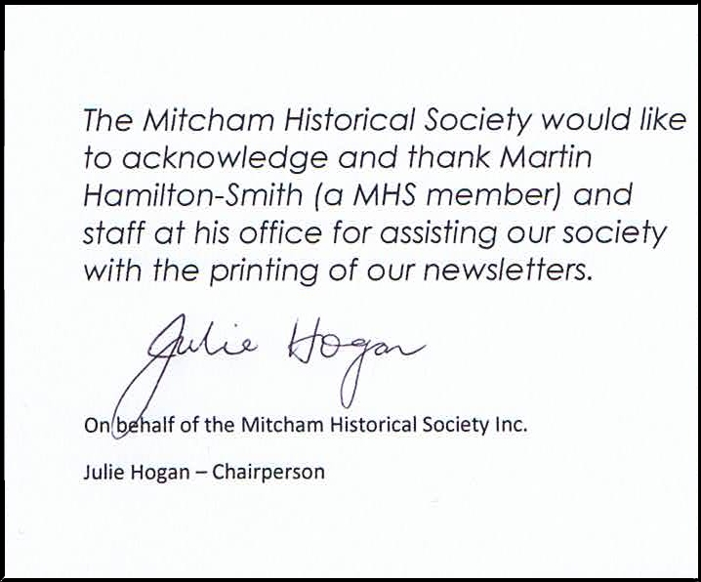

SERIOUS RAILWAY COLLISION. CATTLE TRAIN WRECKED.
TWO FIREMEN KILLED. DRIVERS BADLY INJURED.
N0 PASSENGERS HURT. A MINISTER ON THE TRAIN.

The tidings of a serious railway collision near Walloway, resulting in the death of two firemen and injury to a driver to an extent not yet ascertained, were naturally received in Adelaide with a good deal of consternation, and anxious enquiries as the cause and circumstances of the disaster have been incessant. In a State where the population is scattered over such a large area as that of South Australia railway travelling is a constant necessity, and it is important that the public should feel the utmost confidence in undertaking journeys by this means of transit. Fortunately experience justifies trust in the safety of travel by the iron road. Though the system is extensive, and the volume of traffic large accidents attended with fatal results have been remarkably rare. Indeed, it may be doubted if in any part of the world a better record in this respect could be shown. The principle of State ownership of the railways is firmly established in this State, but the people have realised the imperative necessity of maintaining efficient management of a department which at one time or another has in its custody the safety of life and limb of almost the entire community. The annals of railways the wide world over are full of ghastly records of tragedies caused by errors apparently slight in themselves, but deadly in their issues. Happily possessing as we do, competent officials carefully trained for the responsibilities devolving upon them, we have been singularly free from such catastrophes. The administration of the State has had the wisdom to man the railway system with officers of the best type, and has resolutely set safety before augmented profit, and it cannot be denied that the immunity from serious accident has warranted the action taken. As yet the official enquiry into the circumstances surrounding the sad accident on Saturday morning has only been partly made, and it is too early to attempt to form an opinion as to the cause of the disaster. The facts in themselves appear simple enough. A cattle train from Quorn and a down special, in which the Hon. R. W. Foster (Commissioner of Public Works] travelling from Petersburg, came into collision, and telescoped about 300 yards south of Walloway station. They were both specials, and the intention was that they should pass each other at the Walloway siding. Each driver, according to the statement made to a representative or "The Advertiser" by Mr. Pendelton, had a timetable, showing that this was to be the passing point. How it happened that the up train proceeded from the appointed spot before the other had passed through is a matter which will doubtless be elucidated at the inquest, over which Mr. Halcomb presides to-day. At half-past 2 in the morning it was, of course, dark, and it appears that the lightning, which flashed at intervals, was of a particularly dazzling character. Whether these facts in any way at the inquest, over which Mr. Halcomb presides to-day. At half-past 2 in the morning it was, of course, dark, and it appears that the lightning, which flashed at intervals, was of a particularly dazzling character. Whether these facts in any way contributed to the mistake, those whose duty it is to investigate, and who will be assisted by the best expert opinion, may be able to decide. The statement of a driver who knows the district well that the night was the worst he had ever experienced during a long connection with the railway service, seems to imply that the conditions alluded to may have been responsible for the unhappy event. If, too, the line was in a slippery condition, either from the presence of grasshoppers or from any other cause, there might be difficulty in stopping a long and heavy train on a declining grade, even if the siding were seen. Serious as the accident has proved, it seems almost a miracle that a greater number of lives were not sacrificed through it. Indeed, the wonder is that anyone should have escaped. Through the coupling of the carriage in which Mr. Foster travelled breaking, that portion of the train became detached, and ran backward. This probably saved those in this portion of the train from any injury beyond a shock.
Orroroo, November 16.

A terrible railway accident occurred about a quarter of a mile on this side on the Walloway siding this morning about half-past 2 o'clock. A cattle train from Quorn collided with a special from Petersburg, both firemen, Eager and Brodie, being killed, and Driver Pennington seriously injured. To the down special was attached a carriage containing the Hon. R. W. Foster (Commissioner of Public Works) and five other passengers. It was very dark when the collision occurred, and it was with difficulty that the injured men were extricated from the wreck. Eager, the fireman of the up train, must have been killed almost instantly, his body being discovered suspended across the driving bar. Brodie's leg was jambed between the cabin and tender, and was cut off close to the body. He lingered for over two hours and was sensible to the last. Pennington was found in the culvert immediately over which the accident occurred almost buried in the debris, composed of broken trucks and dead cattle. Four cattle trucks were derailed and smashed. About twenty cattle were killed, others being considerably injured. The five trucks immediately behind the engine of the down train, containing copper ore and flour, were telescoped, and driven under the tender, the upending of which was the immediate cause of Brodie's death. Driver Haines was thrown a considerable distance from the train, but was not seriously hurt. The Commissioner stated that the guard of each train was supplied with crossing sheets, and both were timed to cross at Walloway. The reason they did not do so is not known. Soon after the accident occurred Petersburg was communicated with, and a relief train, containing about 100 workmen, was speedily on the scene. Dr. Strangman, from Orroroo, went out, and the bodies of the dead men were taken to Petersburg, where an inquest will be held to-day. Messrs. Pendleton, McNeil, Moncrieff, McGuire, Fielding, and other railway officials have also gone to the scene of the disaster, and the work of clearing the line is now being proceeded with. The passengers from the north were transferred to a special train, which will probably reach Adelaide about an hour late.
Petersburg, November 16.

Mr. Foster escaped with a slight shaking.

The latter half of his train broke away, and ran back half a mile. He proceeded to Quorn by the afternoon train, and will return to attend the inquest, which is to be held at Petersburg. The jury are leaving Petersburg to view the scene of the accident. The condition of Pennington, the injured driver, is fairly satisfactory. The line is now clear.
(From The Advertiser, Monday 18 November 1901, page 5)
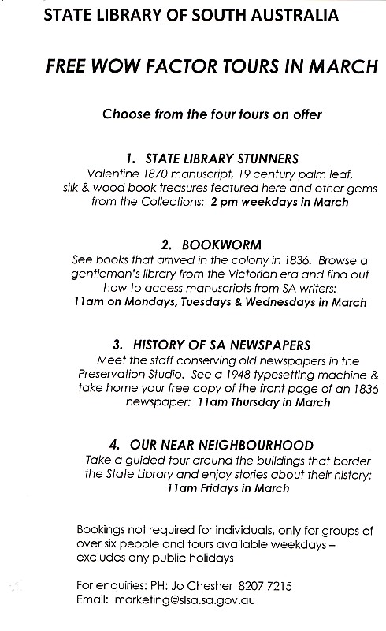

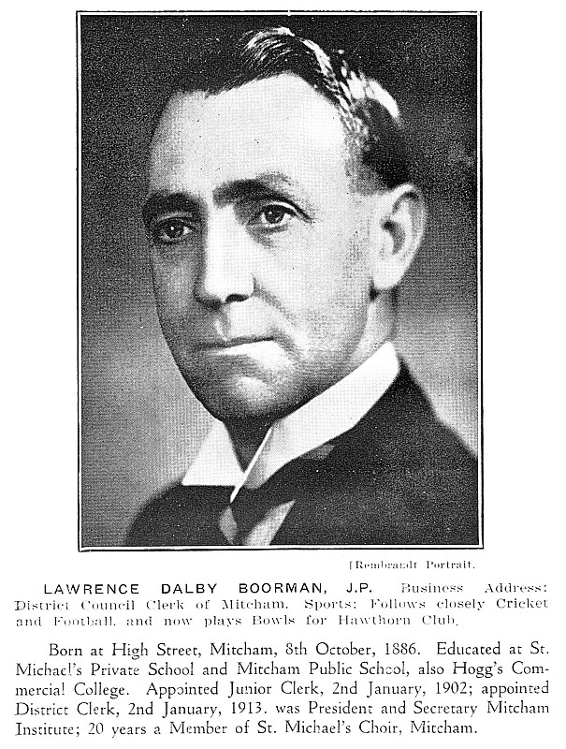
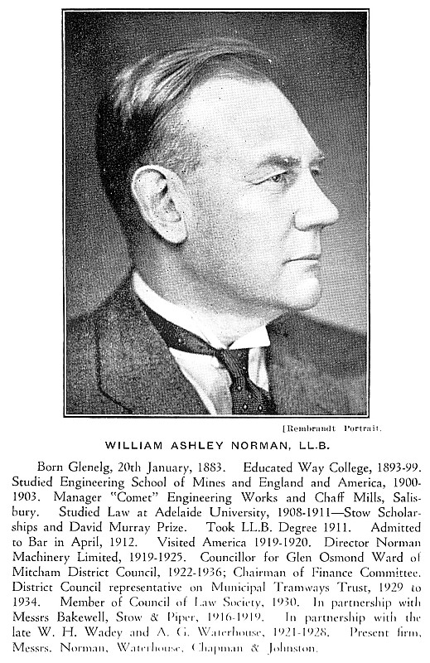

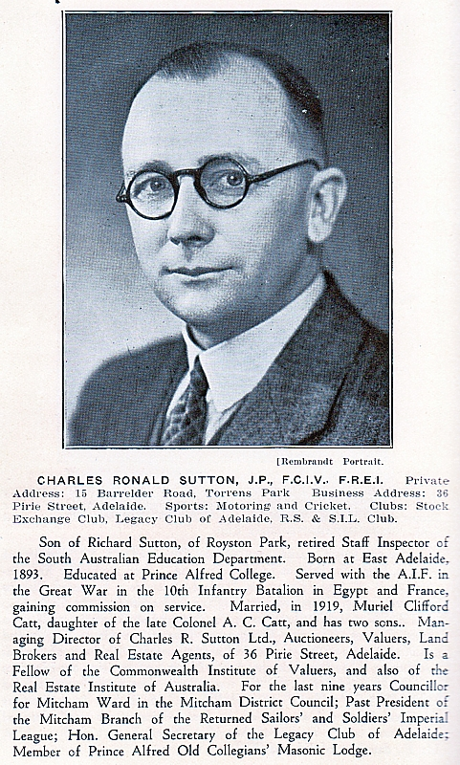
CORPORATE MEMBER LOGOS

It is with pleasure that we present here the Business Logos of our Corporate Members, namely:
The Edinburgh Hotel & Cellars Adelaide Expo Hire Scotch College
Mitcham Antique Gallery Dowling City Country Mitcham Square Newsagency









POSTAGE
PAID
AUSTRALIA
PRINT
POST
PP 536729/00025
If undeliverable return to:
Mitcham Historical Society Inc.
PO Box 903 Mitcham Shopping Centre
S. A. 5062
Mitcham Memories
Print Post Approved
PP 123456/12234

Address Label

Preiss, K and Oborn, P. The Torrens Park Estate, published by the authors, 1991, page 323
S. A. Weekend, 9/10/2010
Preiss, K. and Oborn, P. The Torrens Park Estate 1991, page 220
The Mail, Saturday 11 August, 1928, page 13,
Loosely based on South Australian Register, Friday 25 September 1863, page 2
Loosely based on The South Australian Advertiser, Friday 19 September 1873, page 2
Loosely based on the South Australian Weekly Chronicle, Saturday 15 September 1883, page 22
Loosely based on the South Australian Chronicle, Saturday 28 November 1891, page 23
Loosely based on the South Australian Chronicle, Saturday 28 November 1891, page 23
The Advertiser, Saturday 25 July 1903, page 9, 10

